UNITED STATES
SECURITIES AND EXCHANGE COMMISSION
WASHINGTON, DC 20549
FORM 8-K
CURRENT REPORT
Pursuant to Section 13 or 15(d) of the
Securities Exchange Act of 1934
Date of report (Date of earliest event reported): July 22, 2026

FIVE STAR BANCORP
(Exact Name of Registrant as Specified in Charter)
California |  |  |  |  |  | 001-40379 |  |  |  |  |  | 75-3100966
(State or Other Jurisdiction  of Incorporation) |  |  |  |  |  | (Commission  File Number) |  |  |  |  |  | (I.R.S. Employer  Identification No.)

3100 Zinfandel Drive, Suite 100, Rancho Cordova, California, 95670
(Address of Principal Executive Offices, and Zip Code)

(916) 626-5000
Registrant’s Telephone Number, Including Area Code

Not Applicable
(Former Name or Former Address, if Changed Since Last Report)
Check the appropriate box below if the Form 8-K filing is intended to simultaneously satisfy the filing obligation of the registrant under any of the following provisions (see General Instruction A.2. below):

 |  |  | ☐ |  |  | Written communication pursuant to Rule 425 under the Securities Act (17 CFR 230.425)

 |  |  | ☐ |  |  | Soliciting material pursuant to Rule 14a-12 under the Exchange Act (17 CFR 240.14a-12)

 |  |  | ☐ |  |  | Pre-commencement communication pursuant to Rule 14d-2(b) under the Exchange Act (17 CFR 240.14d-2(b))
 |  |  | ☐ |  |  | Pre-commencement communication pursuant to Rule 13e-4(c) under the Exchange Act (17 CFR 240.13e-4(c))
Securities registered pursuant to Section 12(b) of the Act:
Title of each class |  |  | Trading Symbol(s) |  |  | Name of each exchange on which registered
Common Stock, no par value per share |  |  | FSBC |  |  | The Nasdaq Stock Market LLC
Indicate by check mark whether the registrant is an emerging growth company as defined in Rule 405 of the Securities Act of 1933 (17 CFR §230.405) or Rule 12b-2 of the Securities Exchange Act of 1934 (17 CFR §240.12b-2). Emerging growth company ☑
If an emerging growth company, indicate by check mark if the registrant has elected not to use the extended transition period for complying with any new or revised financial accounting standards provided pursuant to Section 13(a) of the Exchange Act. ☐

Item 2.02 Results of Operations and Financial Condition
On July 22, 2026, Five Star Bancorp (the “Company”) issued a press release announcing its results of operations and financial condition for the quarter ended June 30, 2026. A copy of the press release is attached to this Current Report on Form 8-K as Exhibit 99.1 and is incorporated herein by reference.
This information (including Exhibit 99.1) is being furnished under Item 2.02 hereof and shall not be deemed “filed” for purposes of Section 18 of the Securities Exchange Act of 1934, as amended (the “Exchange Act”), or otherwise subject to the liabilities of that section, and such information shall not be deemed incorporated by reference into any filing under the Securities Act of 1933, as amended (the “Securities Act”), or the Exchange Act, except as shall be expressly set forth by specific reference in such filing.

Item 7.01 Regulation FD Disclosure
The Company is conducting an earnings call on July 23, 2026 at 10:00 AM PT/1:00 PM ET to discuss its second quarter 2026 financial results. A copy of the investor presentation to be used during the earnings call is attached to this Current Report on Form 8-K as Exhibit 99.2 and is incorporated herein by reference.
This information (including Exhibit 99.2) is being furnished under Item 7.01 hereof and shall not be deemed “filed” for purposes of Section 18 of the Exchange Act, or otherwise subject to the liabilities of that section, and such information shall not be deemed incorporated by reference into any filing under the Securities Act, or the Exchange Act, except as shall be expressly set forth by specific reference in such filing.

Item 9.01 Financial Statements and Exhibits
(d) Exhibits
Number |  |  |  |  |  |  |  |  | Description
99.1 |  |  |  |  |  |  |  |  | Press Release dated July 22, 2026
99.2 |  |  |  |  |  |  |  |  | Second Quarter 2026 Investor Presentation, dated July 23, 2026
104 |  |  |  |  |  |  |  |  | Cover Page Interactive Data File (embedded within the Inline XBRL)

SIGNATURE
Pursuant to the requirements of the Securities Exchange Act of 1934, the registrant has duly caused this report to be signed on its behalf by the undersigned hereunto duly authorized.
 |  |  | FIVE STAR BANCORP
 |  |  | By: |  |  | /s/ Heather C. Luck
 |  |  |  |  |  | Name: Heather C. Luck
 |  |  |  |  |  | Title: Executive Vice President and Chief Financial Officer
Date: July 22, 2026

PRESS RELEASE |  |  | FOR IMMEDIATE RELEASE

Five Star Bancorp Announces Second Quarter 2026 Results
RANCHO CORDOVA, CA July 22, 2026 (GLOBE NEWSWIRE) – Five Star Bancorp (Nasdaq: FSBC) (“Five Star” or the “Company”), a holding company that operates through its wholly owned banking subsidiary, Five Star Bank (the “Bank”), today reported net income of $19.4 million for the three months ended June 30, 2026, as compared to $18.6 million for the three months ended March 31, 2026 and $14.5 million for the three months ended June 30, 2025.

Second Quarter Highlights
Performance and operating highlights for the Company for the periods noted below included the following:
 |  |  | Three months ended
(in thousands, except per share and share data) |  |  | June 30,  2026 |  |  |  |  |  | March 31,  2026 |  |  |  |  |  | June 30,  2025
Return on average assets (“ROAA”) |  |  | 1.49 |  | % |  |  |  | 1.55 |  | % |  |  |  | 1.37 |  | %
Return on average equity (“ROAE”) |  |  | 16.67 |  | % |  |  |  | 16.73 |  | % |  |  |  | 14.17 |  | %
Pre-tax income |  |  | $ | 26,089 |  |  |  |  | $ | 25,031 |  |  |  |  | $ | 20,099
Pre-tax, pre-provision income(1) |  |  | $ | 28,339 |  |  |  |  | $ | 27,706 |  |  |  |  | $ | 22,599
Net income |  |  | $ | 19,399 |  |  |  |  | $ | 18,621 |  |  |  |  | $ | 14,508
Basic earnings per common share |  |  | $ | 0.91 |  |  |  |  | $ | 0.87 |  |  |  |  | $ | 0.68
Diluted earnings per common share |  |  | $ | 0.91 |  |  |  |  | $ | 0.87 |  |  |  |  | $ | 0.68
Weighted average basic common shares outstanding |  |  | 21,273,902 |  |  |  |  |  | 21,253,085 |  |  |  |  |  | 21,225,831
Weighted average diluted common shares outstanding |  |  | 21,338,903 |  |  |  |  |  | 21,313,078 |  |  |  |  |  | 21,269,265
Shares outstanding at end of period |  |  | 21,402,864 |  |  |  |  |  | 21,376,153 |  |  |  |  |  | 21,360,991
(1) See the section entitled “Non-GAAP Reconciliation (Unaudited)” for a reconciliation of this non-GAAP financial measure.
James E. Beckwith, President and Chief Executive Officer, commented:
“Five Star Bank’s differentiated customer experience and reputation continue to power demand for our services. In the second quarter of 2026, we are pleased that net income increased to $19.4 million, compared to $18.6 million for the first quarter of 2026, and earnings per share increased to $0.91, up $0.04 from the first quarter of 2026 and up $0.23 from the second quarter of 2025. Net interest margin decreased by seven basis points to 3.63%. Total loans held for investment increased by $306.3 million, or 7% (approximately 29% when annualized), and total deposits increased by $330.0 million, or 7% (approximately 30% when annualized). We are also pleased with the continued execution of our strategic plan, including the payment of a cash dividend of $0.25 per share to shareholders. In the second quarter, Five Star Bank was honored to be named the Best Place to Work by the San Francisco Business Times, ranking first overall among participating businesses with 25 to 49 employees in the San Francisco Bay Area. This recognition reflects our purpose-driven culture, which is a meaningful differentiator and an important contributor to our continued performance. I am proud of our team’s accomplishments and look forward to the continued momentum of our organic growth story.”
Financial highlights as of and during the three months ended June 30, 2026 included the following:
•Total deposits increased by $330.0 million, or 7.38%, during the three months ended June 30, 2026, with growth in non-wholesale deposits exceeding declines in wholesale deposits. The Company defines wholesale deposits as brokered deposits and California Time Deposit Program deposits. During the three months ended June 30, 2026, non-wholesale deposits increased by $463.1 million, or 11.33%, and wholesale deposits decreased by $133.1 million, or 34.74%.
1
•The number of Business Development Officers increased from 43 at March 31, 2026 to 45 at June 30, 2026.
•Cash and cash equivalents were $685.1 million, representing 14.27% of total deposits at June 30, 2026, as compared to 14.42% at March 31, 2026.
•Consistent, disciplined management of expenses contributed to our efficiency ratio of 40.91% for the three months ended June 30, 2026, as compared to 38.57% for the three months ended March 31, 2026 and 41.03% for the three months ended June 30, 2025.
•Net interest margin expanded by 10 basis points year-over-year, increasing from 3.53% for the three months ended June 30, 2025 to 3.63% for the three months ended June 30, 2026, demonstrating the Company's ability to grow its margin even as the effective federal funds rate declined 70 basis points over the same period from 4.33% at June 30, 2025 to 3.63% at June 30, 2026. Net interest margin for the three months ended June 30, 2026 contracted by seven basis points from 3.70% for the three months ended March 31, 2026, reflecting that strong quarter-over-quarter growth in net interest income was primarily volume driven, as rapid balance sheet expansion modestly diluted the overall yield on earning assets.
•Other comprehensive income was $0.7 million during the three months ended June 30, 2026. Unrealized losses, net of tax effect, on available-for-sale securities were $9.4 million as of June 30, 2026. Total carrying value of held-to-maturity and available-for-sale securities represented 0.04% and 1.72% of total interest-earning assets, respectively, as of June 30, 2026.
•The Company’s common equity Tier 1 capital ratio was 9.98% and 10.45% as of June 30, 2026 and March 31, 2026, respectively. The Bank continues to meet all requirements to be considered “well-capitalized” under applicable regulatory guidelines.
•Loan and deposit growth as of the dates provided below was as follows:
(in thousands) |  |  | June 30,  2026 |  |  |  |  |  | March 31,  2026 |  |  |  |  |  | $ Change |  |  |  |  |  | % Change
Loans held for investment |  |  | $ | 4,519,681 |  |  |  |  | $ | 4,213,393 |  |  |  |  | $ | 306,288 |  |  |  |  | 7.27 |  | %
Non-interest-bearing deposits |  |  | 1,174,406 |  |  |  |  |  | 1,232,696 |  |  |  |  |  | (58,290) |  |  |  |  |  | (4.73) |  | %
Interest-bearing deposits |  |  | 3,624,977 |  |  |  |  |  | 3,236,657 |  |  |  |  |  | 388,320 |  |  |  |  |  | 12.00 |  | %
(in thousands) |  |  | June 30,  2026 |  |  |  |  |  | June 30,  2025 |  |  |  |  |  | $ Change |  |  |  |  |  | % Change
Loans held for investment |  |  | $ | 4,519,681 |  |  |  |  | $ | 3,758,025 |  |  |  |  | $ | 761,656 |  |  |  |  | 20.27 |  | %
Non-interest-bearing deposits |  |  | 1,174,406 |  |  |  |  |  | 1,004,061 |  |  |  |  |  | 170,345 |  |  |  |  |  | 16.97 |  | %
Interest-bearing deposits |  |  | 3,624,977 |  |  |  |  |  | 2,890,561 |  |  |  |  |  | 734,416 |  |  |  |  |  | 25.41 |  | %
•The ratio of nonperforming loans to loans held for investment at period end increased from 0.07% at March 31, 2026 to 0.30% at June 30, 2026, due to one Community Reinvestment Act loan that was placed on non-accrual status. The balance of the loan is $11.4 million as of June 30, 2026 and was originally downgraded to substandard in 2025.
•The Company’s Board of Directors declared, and the Company subsequently paid, a cash dividend of $0.25 per share during the three months ended June 30, 2026. The Company’s Board of Directors declared an additional cash dividend of $0.25 per share on July 16, 2026, which the Company expects to pay on August 10, 2026 to shareholders of record as of August 3, 2026.

2
Summary Results
Three months ended June 30, 2026, as compared to three months ended March 31, 2026
The Company’s net income was $19.4 million for the three months ended June 30, 2026, as compared to $18.6 million for the three months ended March 31, 2026. Net interest income increased by $2.6 million during the three months ended June 30, 2026, as compared to the three months ended March 31, 2026, primarily due to an increase in interest income driven by loan growth and higher interest-earning deposits in banks, partially offset by an increase in interest expense driven by deposit growth. The provision for credit losses decreased by $0.4 million during the three months ended June 30, 2026, as compared to the three months ended March 31, 2026, reflecting lower loss estimates driven by strong loan growth concentrated in pools with relatively lower loss rates. Non-interest income increased by $0.2 million during the three months ended June 30, 2026, as compared to the three months ended March 31, 2026, primarily due to an overall improvement in earnings related to investments in venture-backed funds, partially offset by lower fees from swap referrals, and the absence of a special FHLB stock dividend. Non-interest expense increased by $2.2 million during the three months ended June 30, 2026, as compared to the three months ended March 31, 2026, primarily due to a $1.0 million loss contingency release on a U.S. Small Business Administration (“SBA”) loan that benefitted the three months ended March 31, 2026, which did not reoccur during the three months ended June 30, 2026, as well as higher advertising, promotional, data processing, and software expenses tied to continued organizational growth.
Three months ended June 30, 2026, as compared to three months ended June 30, 2025
The Company’s net income was $19.4 million for the three months ended June 30, 2026, as compared to $14.5 million for the three months ended June 30, 2025. Net interest income increased by $9.6 million during the three months ended June 30, 2026, as compared to the three months ended June 30, 2025, primarily due to an increase in interest income driven by loan growth and higher interest-earning deposits in banks, partially offset by an increase in interest expense driven by deposit growth, though moderated by a decrease in the average cost of deposits. The provision for credit losses decreased by $0.3 million, reflecting lower net charge-offs in the three months ended June 30, 2026 compared to the three months ended June 30, 2025. Non-interest income increased by $0.1 million during the three months ended June 30, 2026, as compared to the three months ended June 30, 2025, primarily reflecting higher loan referral income and fees from swap referrals, as well as an overall improvement in earnings related to investments in venture-backed funds. These increases were partially offset by lower FHLB stock dividends and an intentional reduction in gain on sale of loans. Non-interest expense increased by $3.9 million during the three months ended June 30, 2026, as compared to the three months ended June 30, 2025, driven primarily by increased salaries and employee benefits from increased headcount, along with growth in other operating expenses reflecting continued organizational expansion.
3
The following is a summary of the components of the Company’s operating results and performance ratios for the periods indicated:
 |  |  |  |  |  | Three months ended
(in thousands, except per share data) |  |  |  |  |  | June 30,  2026 |  |  |  |  |  | March 31,  2026 |  |  |  |  |  | $ Change |  |  |  |  |  | % Change
Selected operating data:
Net interest income |  |  |  |  |  | $ | 46,083 |  |  |  |  | $ | 43,457 |  |  |  |  | $ | 2,626 |  |  |  |  | 6.04 |  | %
Provision for credit losses |  |  |  |  |  | 2,250 |  |  |  |  |  | 2,675 |  |  |  |  |  | (425) |  |  |  |  |  | (15.89) |  | %
Non-interest income |  |  |  |  |  | 1,872 |  |  |  |  |  | 1,643 |  |  |  |  |  | 229 |  |  |  |  |  | 13.94 |  | %
Non-interest expense |  |  |  |  |  | 19,616 |  |  |  |  |  | 17,394 |  |  |  |  |  | 2,222 |  |  |  |  |  | 12.77 |  | %
Pre-tax income |  |  |  |  |  | 26,089 |  |  |  |  |  | 25,031 |  |  |  |  |  | 1,058 |  |  |  |  |  | 4.23 |  | %
Provision for income taxes |  |  |  |  |  | 6,690 |  |  |  |  |  | 6,410 |  |  |  |  |  | 280 |  |  |  |  |  | 4.37 |  | %
Net income |  |  |  |  |  | $ | 19,399 |  |  |  |  | $ | 18,621 |  |  |  |  | $ | 778 |  |  |  |  | 4.18 |  | %
Earnings per common share:
Basic |  |  |  |  |  | $ | 0.91 |  |  |  |  | $ | 0.87 |  |  |  |  | $ | 0.04 |  |  |  |  | 4.60 |  | %
Diluted |  |  |  |  |  | $ | 0.91 |  |  |  |  | $ | 0.87 |  |  |  |  | $ | 0.04 |  |  |  |  | 4.60 |  | %
Performance and other financial ratios:
ROAA |  |  |  |  |  | 1.49 |  | % |  |  |  | 1.55 |  | %
ROAE |  |  |  |  |  | 16.67 |  | % |  |  |  | 16.73 |  | %
Net interest margin |  |  |  |  |  | 3.63 |  | % |  |  |  | 3.70 |  | %
Total cost of funds(1) |  |  |  |  |  | 2.23 |  | % |  |  |  | 2.20 |  | %
Efficiency ratio |  |  |  |  |  | 40.91 |  | % |  |  |  | 38.57 |  | %
 |  |  |  |  |  | Three months ended
(in thousands, except per share data) |  |  |  |  |  | June 30,  2026 |  |  |  |  |  | June 30,  2025 |  |  |  |  |  | $ Change |  |  |  |  |  | % Change
Selected operating data:
Net interest income |  |  |  |  |  | $ | 46,083 |  |  |  |  | $ | 36,515 |  |  |  |  | $ | 9,568 |  |  |  |  | 26.20 |  | %
Provision for credit losses |  |  |  |  |  | 2,250 |  |  |  |  |  | 2,500 |  |  |  |  |  | (250) |  |  |  |  |  | (10.00) |  | %
Non-interest income |  |  |  |  |  | 1,872 |  |  |  |  |  | 1,810 |  |  |  |  |  | 62 |  |  |  |  |  | 3.43 |  | %
Non-interest expense |  |  |  |  |  | 19,616 |  |  |  |  |  | 15,726 |  |  |  |  |  | 3,890 |  |  |  |  |  | 24.74 |  | %
Pre-tax income |  |  |  |  |  | 26,089 |  |  |  |  |  | 20,099 |  |  |  |  |  | 5,990 |  |  |  |  |  | 29.80 |  | %
Provision for income taxes |  |  |  |  |  | 6,690 |  |  |  |  |  | 5,591 |  |  |  |  |  | 1,099 |  |  |  |  |  | 19.66 |  | %
Net income |  |  |  |  |  | $ | 19,399 |  |  |  |  | $ | 14,508 |  |  |  |  | $ | 4,891 |  |  |  |  | 33.71 |  | %
Earnings per common share:
Basic |  |  |  |  |  | $ | 0.91 |  |  |  |  | $ | 0.68 |  |  |  |  | $ | 0.23 |  |  |  |  | 33.82 |  | %
Diluted |  |  |  |  |  | $ | 0.91 |  |  |  |  | $ | 0.68 |  |  |  |  | $ | 0.23 |  |  |  |  | 33.82 |  | %
Performance and other financial ratios:
ROAA |  |  |  |  |  | 1.49 |  | % |  |  |  | 1.37 |  | %
ROAE |  |  |  |  |  | 16.67 |  | % |  |  |  | 14.17 |  | %
Net interest margin |  |  |  |  |  | 3.63 |  | % |  |  |  | 3.53 |  | %
Total cost of funds(1) |  |  |  |  |  | 2.23 |  | % |  |  |  | 2.53 |  | %
Efficiency ratio |  |  |  |  |  | 40.91 |  | % |  |  |  | 41.03 |  | %
(1) Total cost of funds reflects the average cost of all funding sources, including both interest-bearing and non-interest-bearing deposits and borrowings.

4
Balance Sheet Summary
(in thousands) |  |  |  |  |  | June 30,  2026 |  |  |  |  |  | March 31,  2026 |  |  |  |  |  | $ Change |  |  |  |  |  | % Change
Selected financial condition data:
Total assets |  |  |  |  |  | $ | 5,377,062 |  |  |  |  | $ | 5,031,751 |  |  |  |  | $ | 345,311 |  |  |  |  | 6.86 |  | %
Cash and cash equivalents |  |  |  |  |  | 685,074 |  |  |  |  |  | 644,359 |  |  |  |  |  | 40,715 |  |  |  |  |  | 6.32 |  | %
Total loans held for investment |  |  |  |  |  | 4,519,681 |  |  |  |  |  | 4,213,393 |  |  |  |  |  | 306,288 |  |  |  |  |  | 7.27 |  | %
Total investments |  |  |  |  |  | 92,719 |  |  |  |  |  | 93,850 |  |  |  |  |  | (1,131) |  |  |  |  |  | (1.21) |  | %
Total liabilities |  |  |  |  |  | 4,903,291 |  |  |  |  |  | 4,573,232 |  |  |  |  |  | 330,059 |  |  |  |  |  | 7.22 |  | %
Total deposits |  |  |  |  |  | 4,799,383 |  |  |  |  |  | 4,469,353 |  |  |  |  |  | 330,030 |  |  |  |  |  | 7.38 |  | %
Subordinated notes, net |  |  |  |  |  | 74,114 |  |  |  |  |  | 74,077 |  |  |  |  |  | 37 |  |  |  |  |  | 0.05 |  | %
Total shareholders’ equity |  |  |  |  |  | 473,771 |  |  |  |  |  | 458,519 |  |  |  |  |  | 15,252 |  |  |  |  |  | 3.33 |  | %
•Insured and collateralized deposits were approximately $3.2 billion, representing 65.80% of total deposits as of June 30, 2026, as compared to 65.55% as of March 31, 2026. Net uninsured and uncollateralized deposits were approximately $1.6 billion as of June 30, 2026, increasing from $1.5 billion at March 31, 2026.
•Non-wholesale deposit balances constituted 94.79% of total deposits as of June 30, 2026, as compared to 91.43% as of March 31, 2026. Deposit relationships of greater than $5 million represented 63.88% of total deposits as of June 30, 2026, as compared to 60.67% as of March 31, 2026, and had an average age of approximately 7.39 years as of June 30, 2026, as compared to 7.98 years as of March 31, 2026.
•Total deposits as of June 30, 2026 were $4.8 billion, an increase of $330.0 million, or 7.38%, from March 31, 2026, comprised of an increase in interest-bearing deposits, partially offset by a decrease in non-interest-bearing deposits.
•Cash and cash equivalents as of June 30, 2026 were $685.1 million, representing 14.27% of total deposits at June 30, 2026, as compared to 14.42% as of March 31, 2026.
•Total liquidity (consisting of cash and cash equivalents as well as unused and immediately available borrowing capacity as set forth below) was approximately $2.3 billion as of June 30, 2026, as compared to $2.2 billion at March 31, 2026.
 |  |  |  |  |  | June 30, 2026
(in thousands) |  |  |  |  |  | Line of Credit |  |  |  |  |  | Letters of Credit Issued |  |  |  |  |  | Borrowings |  |  |  |  |  | Available
Federal Home Loan Bank of San Francisco (“FHLB”) advances |  |  |  |  |  | $ | 1,629,065 |  |  |  |  | $ | 1,297,500 |  |  |  |  | $ | — |  |  |  |  | $ | 331,565
Federal Reserve Discount Window |  |  |  |  |  | 1,074,577 |  |  |  |  |  | — |  |  |  |  |  | — |  |  |  |  |  | 1,074,577
Correspondent bank lines of credit |  |  |  |  |  | 185,000 |  |  |  |  |  | — |  |  |  |  |  | — |  |  |  |  |  | 185,000
Cash and cash equivalents |  |  |  |  |  | — |  |  |  |  |  | — |  |  |  |  |  | — |  |  |  |  |  | 685,074
Total |  |  |  |  |  | $ | 2,888,642 |  |  |  |  | $ | 1,297,500 |  |  |  |  | $ | — |  |  |  |  | $ | 2,276,216
5
(in thousands) |  |  |  |  |  | June 30,  2026 |  |  |  |  |  | December 31,  2025 |  |  |  |  |  | $ Change |  |  |  |  |  | % Change
Selected financial condition data:
Total assets |  |  |  |  |  | 5,377,062 |  |  |  |  |  | 4,754,861 |  |  |  |  |  | 622,201 |  |  |  |  |  | 13.09 |  | %
Cash and cash equivalents |  |  |  |  |  | 685,074 |  |  |  |  |  | 506,851 |  |  |  |  |  | 178,223 |  |  |  |  |  | 35.16 |  | %
Total loans held for investment |  |  |  |  |  | 4,519,681 |  |  |  |  |  | 4,074,929 |  |  |  |  |  | 444,752 |  |  |  |  |  | 10.91 |  | %
Total investments |  |  |  |  |  | 92,719 |  |  |  |  |  | 96,889 |  |  |  |  |  | (4,170) |  |  |  |  |  | (4.30) |  | %
Total liabilities |  |  |  |  |  | 4,903,291 |  |  |  |  |  | 4,309,029 |  |  |  |  |  | 594,262 |  |  |  |  |  | 13.79 |  | %
Total deposits |  |  |  |  |  | 4,799,383 |  |  |  |  |  | 4,201,084 |  |  |  |  |  | 598,299 |  |  |  |  |  | 14.24 |  | %
Subordinated notes, net |  |  |  |  |  | 74,114 |  |  |  |  |  | 74,041 |  |  |  |  |  | 73 |  |  |  |  |  | 0.10 |  | %
Total shareholders’ equity |  |  |  |  |  | 473,771 |  |  |  |  |  | 445,832 |  |  |  |  |  | 27,939 |  |  |  |  |  | 6.27 |  | %
The increase in total assets from December 31, 2025 to June 30, 2026 was primarily comprised of a $444.8 million increase in total loans held for investment and a $178.2 million increase in cash and cash equivalents. The $444.8 million increase in total loans held for investment between December 31, 2025 and June 30, 2026 was a result of $1.0 billion in loan originations and advances, partially offset by $162.1 million and $421.9 million in loan payoffs and paydowns, respectively. The $444.8 million increase in total loans held for investment included $145.0 million in purchased loans within the consumer section of the loan portfolio. The $178.2 million increase in cash and cash equivalents primarily resulted from the net increase in cash inflows from growth in total deposits of $598.3 million and cash outflows from growth in total loans held for investment of $444.8 million.
The increase in total liabilities from December 31, 2025 to June 30, 2026 was primarily due to an increase in deposits of $598.3 million. The increase in deposits was largely due to increases in money market, interest-bearing transaction, and non-interest-bearing deposits of $590.7 million, $156.1 million, and $89.9 million, respectively, partially offset by a $246.6 million decrease in time deposits, mainly attributable to a $215.0 million decline in wholesale deposits.
The increase in total shareholders’ equity from December 31, 2025 to June 30, 2026 was primarily a result of $38.0 million recognized as net income during the period, partially offset by $10.7 million in cash dividends paid during the period and a $0.3 million increase in accumulated other comprehensive loss.

Net Interest Income and Net Interest Margin
The following is a summary of the components of net interest income for the periods indicated:
 |  |  |  |  |  | Three months ended
(in thousands) |  |  |  |  |  | June 30,  2026 |  |  |  |  |  | March 31,  2026 |  |  |  |  |  | $ Change |  |  |  |  |  | % Change
Interest and fee income |  |  |  |  |  | $ | 72,327 |  |  |  |  | $ | 67,347 |  |  |  |  | $ | 4,980 |  |  |  |  | 7.39 |  | %
Interest expense |  |  |  |  |  | 26,244 |  |  |  |  |  | 23,890 |  |  |  |  |  | 2,354 |  |  |  |  |  | 9.85 |  | %
Net interest income |  |  |  |  |  | $ | 46,083 |  |  |  |  | $ | 43,457 |  |  |  |  | $ | 2,626 |  |  |  |  | 6.04 |  | %
Net interest margin |  |  |  |  |  | 3.63 |  | % |  |  |  | 3.70 |  | %
 |  |  |  |  |  | Three months ended
(in thousands) |  |  |  |  |  | June 30,  2026 |  |  |  |  |  | June 30,  2025 |  |  |  |  |  | $ Change |  |  |  |  |  | % Change
Interest and fee income |  |  |  |  |  | $ | 72,327 |  |  |  |  | $ | 60,580 |  |  |  |  | $ | 11,747 |  |  |  |  | 19.39 |  | %
Interest expense |  |  |  |  |  | 26,244 |  |  |  |  |  | 24,065 |  |  |  |  |  | 2,179 |  |  |  |  |  | 9.05 |  | %
Net interest income |  |  |  |  |  | $ | 46,083 |  |  |  |  | $ | 36,515 |  |  |  |  | $ | 9,568 |  |  |  |  | 26.20 |  | %
Net interest margin |  |  |  |  |  | 3.63 |  | % |  |  |  | 3.53 |  | %

6
The following table shows the components of net interest income and net interest margin for the quarterly periods indicated:
 |  |  |  |  |  | Three months ended
 |  |  |  |  |  | June 30, 2026 |  |  |  |  |  |  |  |  |  |  |  |  |  |  |  |  |  | March 31, 2026 |  |  |  |  |  |  |  |  |  |  |  |  |  |  |  |  |  | June 30, 2025
(in thousands) |  |  |  |  |  | Average  Balance |  |  |  |  |  | Interest  Income/  Expense |  |  |  |  |  | Yield/ Rate |  |  |  |  |  | Average  Balance |  |  |  |  |  | Interest  Income/  Expense |  |  |  |  |  | Yield/ Rate |  |  |  |  |  | Average  Balance |  |  |  |  |  | Interest  Income/  Expense |  |  |  |  |  | Yield/ Rate
Assets
Interest-earning deposits in banks |  |  |  |  |  | $ | 677,149 |  |  |  |  | $ | 6,253 |  |  |  |  | 3.70 |  | % |  |  |  | $ | 512,308 |  |  |  |  | $ | 4,687 |  |  |  |  | 3.71 |  | % |  |  |  | $ | 361,866 |  |  |  |  | $ | 3,987 |  |  |  |  | 4.42 |  | %
Investment securities |  |  |  |  |  | 93,553 |  |  |  |  |  | 509 |  |  |  |  |  | 2.18 |  | % |  |  |  | 96,787 |  |  |  |  |  | 544 |  |  |  |  |  | 2.28 |  | % |  |  |  | 97,886 |  |  |  |  |  | 577 |  |  |  |  |  | 2.37 |  | %
Loans held for investment and sale |  |  |  |  |  | 4,328,304 |  |  |  |  |  | 65,565 |  |  |  |  |  | 6.08 |  | % |  |  |  | 4,150,446 |  |  |  |  |  | 62,116 |  |  |  |  |  | 6.07 |  | % |  |  |  | 3,691,616 |  |  |  |  |  | 56,016 |  |  |  |  |  | 6.09 |  | %
Total interest-earning assets |  |  |  |  |  | 5,099,006 |  |  |  |  |  | 72,327 |  |  |  |  |  | 5.69 |  | % |  |  |  | 4,759,541 |  |  |  |  |  | 67,347 |  |  |  |  |  | 5.74 |  | % |  |  |  | 4,151,368 |  |  |  |  |  | 60,580 |  |  |  |  |  | 5.85 |  | %
Interest receivable and other assets, net |  |  |  |  |  | 123,354 |  |  |  |  |  |  |  |  |  |  |  |  |  |  |  |  |  | 118,967 |  |  |  |  |  |  |  |  |  |  |  |  |  |  |  |  |  | 101,632
Total assets |  |  |  |  |  | $ | 5,222,360 |  |  |  |  |  |  |  |  |  |  |  |  |  |  |  |  | $ | 4,878,508 |  |  |  |  |  |  |  |  |  |  |  |  |  |  |  |  | $ | 4,253,000
Liabilities and shareholders’ equity
Interest-bearing transaction accounts |  |  |  |  |  | $ | 389,136 |  |  |  |  | $ | 1,297 |  |  |  |  | 1.34 |  | % |  |  |  | $ | 343,663 |  |  |  |  | $ | 1,133 |  |  |  |  | 1.34 |  | % |  |  |  | $ | 283,369 |  |  |  |  | $ | 1,043 |  |  |  |  | 1.48 |  | %
Savings accounts |  |  |  |  |  | 143,818 |  |  |  |  |  | 844 |  |  |  |  |  | 2.35 |  | % |  |  |  | 138,125 |  |  |  |  |  | 830 |  |  |  |  |  | 2.44 |  | % |  |  |  | 121,692 |  |  |  |  |  | 801 |  |  |  |  |  | 2.64 |  | %
Money market accounts |  |  |  |  |  | 2,556,482 |  |  |  |  |  | 19,318 |  |  |  |  |  | 3.03 |  | % |  |  |  | 2,185,347 |  |  |  |  |  | 15,851 |  |  |  |  |  | 2.94 |  | % |  |  |  | 1,647,628 |  |  |  |  |  | 13,270 |  |  |  |  |  | 3.23 |  | %
Time accounts |  |  |  |  |  | 396,923 |  |  |  |  |  | 3,623 |  |  |  |  |  | 3.66 |  | % |  |  |  | 531,031 |  |  |  |  |  | 4,915 |  |  |  |  |  | 3.75 |  | % |  |  |  | 726,295 |  |  |  |  |  | 7,790 |  |  |  |  |  | 4.30 |  | %
Subordinated notes and other borrowings |  |  |  |  |  | 74,091 |  |  |  |  |  | 1,162 |  |  |  |  |  | 6.29 |  | % |  |  |  | 74,072 |  |  |  |  |  | 1,161 |  |  |  |  |  | 6.36 |  | % |  |  |  | 73,967 |  |  |  |  |  | 1,161 |  |  |  |  |  | 6.30 |  | %
Total interest-bearing liabilities |  |  |  |  |  | 3,560,450 |  |  |  |  |  | 26,244 |  |  |  |  |  | 2.96 |  | % |  |  |  | 3,272,238 |  |  |  |  |  | 23,890 |  |  |  |  |  | 2.96 |  | % |  |  |  | 2,852,951 |  |  |  |  |  | 24,065 |  |  |  |  |  | 3.38 |  | %
Demand accounts |  |  |  |  |  | 1,163,991 |  |  |  |  |  |  |  |  |  |  |  |  |  |  |  |  |  | 1,122,062 |  |  |  |  |  |  |  |  |  |  |  |  |  |  |  |  |  | 957,034
Interest payable and other liabilities |  |  |  |  |  | 31,140 |  |  |  |  |  |  |  |  |  |  |  |  |  |  |  |  |  | 32,739 |  |  |  |  |  |  |  |  |  |  |  |  |  |  |  |  |  | 32,406
Shareholders’ equity |  |  |  |  |  | 466,779 |  |  |  |  |  |  |  |  |  |  |  |  |  |  |  |  |  | 451,469 |  |  |  |  |  |  |  |  |  |  |  |  |  |  |  |  |  | 410,609
Total liabilities & shareholders’ equity |  |  |  |  |  | $ | 5,222,360 |  |  |  |  |  |  |  |  |  |  |  |  |  |  |  |  | $ | 4,878,508 |  |  |  |  |  |  |  |  |  |  |  |  |  |  |  |  | $ | 4,253,000
Net interest spread |  |  |  |  |  |  |  |  |  |  |  |  |  |  |  |  |  | 2.73 |  | % |  |  |  |  |  |  |  |  |  |  |  |  |  |  |  | 2.78 |  | % |  |  |  |  |  |  |  |  |  |  |  |  |  |  |  | 2.47 |  | %
Net interest income/margin |  |  |  |  |  |  |  |  |  |  |  | $ | 46,083 |  |  |  |  | 3.63 |  | % |  |  |  |  |  |  |  |  |  | $ | 43,457 |  |  |  |  | 3.70 |  | % |  |  |  |  |  |  |  |  |  | $ | 36,515 |  |  |  |  | 3.53 |  | %

7
Net interest income during the three months ended June 30, 2026 increased by $2.6 million, or 6.04%, to $46.1 million, as compared to $43.5 million during the three months ended March 31, 2026. Net interest margin totaled 3.63% for the three months ended June 30, 2026, a decrease of seven basis points compared to the prior quarter, reflecting that strong quarter-over-quarter growth in net interest income was primarily volume driven, as rapid balance sheet expansion modestly diluted the overall yield on earning assets. The increase in net interest income is primarily attributable to a $5.0 million increase in interest income, mainly due to a $177.9 million, or 4.29%, increase in the average balance of loans and a $164.8 million, or 32.18%, increase in the average balance of interest-earning deposits in banks (deposits placed with other financial institutions to earn interest). The increase in interest income was partially offset by a $2.4 million increase in interest expense due to a $330.1 million, or 7.64%, increase in the average balance of deposits, combined with a three basis point increase in the average cost of deposits. The average balance of non-interest bearing deposits increased by $41.9 million, or 3.74%, quarter-over-quarter, helping to partially offset the rise in deposit funding costs.
As compared to the three months ended June 30, 2025, net interest income during the three months ended June 30, 2026 increased by $9.6 million, or 26.20%, to $46.1 million from $36.5 million. Net interest margin totaled 3.63% for the three months ended June 30, 2026, an increase of 10 basis points compared to the same quarter of the prior year. The improvement was driven by balance sheet growth and a favorable shift in funding mix, which more than offset pressure from declining federal funds rates over the same period. The increase in net interest income is primarily attributable to an $11.7 million increase in interest income, mainly due to a $636.7 million, or 17.25%, increase in the average balance of loans and a $315.3 million, or 87.13%, increase in the average balance of interest-earning deposits in banks (deposits placed with other financial institutions to earn interest). This increase in interest income was partially offset by a $2.2 million increase in interest expense, stemming from a $914.3 million, or 24.47%, increase in the average balance of deposits during the three months ended June 30, 2026, moderated by a 30 basis point decrease in average cost of deposits compared to the same quarter of the prior year. Further supporting the decreasing average cost of deposits, the average balance of non-interest-bearing deposits increased by $207.0 million, or 21.62%, compared to the same period of the prior year.

Loans by Type
The following table provides loan balances, excluding deferred loan fees, by type as of the dates shown:
(in thousands) |  |  |  |  |  | June 30, 2026 |  |  |  |  |  | March 31, 2026
Real estate:
Commercial |  |  |  |  |  | $ | 3,597,173 |  |  |  |  | $ | 3,421,902
Commercial land and development |  |  |  |  |  | 2,507 |  |  |  |  |  | 2,519
Commercial construction |  |  |  |  |  | 124,053 |  |  |  |  |  | 108,179
Residential construction |  |  |  |  |  | 21,809 |  |  |  |  |  | 17,808
Residential |  |  |  |  |  | 41,874 |  |  |  |  |  | 43,195
Farmland |  |  |  |  |  | 59,900 |  |  |  |  |  | 61,090
Commercial:
Secured |  |  |  |  |  | 258,736 |  |  |  |  |  | 243,140
Unsecured |  |  |  |  |  | 41,263 |  |  |  |  |  | 41,971
Consumer and other |  |  |  |  |  | 374,614 |  |  |  |  |  | 275,891
Net deferred loan fees |  |  |  |  |  | (2,248) |  |  |  |  |  | (2,302)
Total loans held for investment |  |  |  |  |  | $ | 4,519,681 |  |  |  |  | $ | 4,213,393

Interest-bearing Deposits
The following table provides interest-bearing deposit balances by type as of the dates shown:
(in thousands) |  |  |  |  |  | June 30, 2026 |  |  |  |  |  | March 31, 2026
Interest-bearing transaction accounts |  |  |  |  |  | $ | 500,256 |  |  |  |  | $ | 349,138
Savings accounts |  |  |  |  |  | 147,435 |  |  |  |  |  | 141,961
Money market accounts |  |  |  |  |  | 2,669,295 |  |  |  |  |  | 2,291,215
Time accounts |  |  |  |  |  | 307,991 |  |  |  |  |  | 454,343
Total interest-bearing deposits |  |  |  |  |  | $ | 3,624,977 |  |  |  |  | $ | 3,236,657

8
Asset Quality

Allowance for Credit Losses
At June 30, 2026, the Company’s allowance for credit losses was $47.3 million, as compared to $44.4 million at December 31, 2025. The $2.9 million increase in the allowance is due to a $4.6 million provision for credit losses recorded during the six months ended June 30, 2026, partially offset by net charge-offs of $1.6 million, primarily attributable to commercial and industrial loans, during the same period.
The Company’s nonperforming loans increased from $3.1 million to $13.4 million between December 31, 2025 and June 30, 2026, increasing the ratio of nonperforming loans to loans held for investment from 0.08% at December 31, 2025 to 0.30% at June 30, 2026. This increase was due to one Community Reinvestment Act loan that was placed on non-accrual status during the period. The balance of the loan is $11.4 million as of June 30, 2026, and it was originally downgraded to substandard in 2025. This was partially offset by improvements across the remainder of the nonperforming loan portfolio. Loans designated as watch increased from $101.9 million to $154.6 million between December 31, 2025 and June 30, 2026. Loans designated as special mention increased from $37.5 million to $44.9 million between December 31, 2025 and June 30, 2026. Loans designated as substandard decreased from $22.3 million to $20.3 million between December 31, 2025 and June 30, 2026. There were no loans with doubtful risk grades at June 30, 2026 or December 31, 2025.
A summary of the allowance for credit losses by loan class is as follows:
 |  |  |  |  |  | June 30, 2026 |  |  |  |  |  |  |  |  |  |  |  | December 31, 2025
(in thousands) |  |  |  |  |  | Amount |  |  |  |  |  | % of Total |  |  |  |  |  | Amount |  |  |  |  |  | % of Total
Real estate:
Commercial |  |  |  |  |  | $ | 28,371 |  |  |  |  | 59.92 |  | % |  |  |  | $ | 25,219 |  |  |  |  | 56.77 |  | %
Commercial land and development |  |  |  |  |  | 90 |  |  |  |  |  | 0.19 |  | % |  |  |  | 56 |  |  |  |  |  | 0.13 |  | %
Commercial construction |  |  |  |  |  | 4,444 |  |  |  |  |  | 9.39 |  | % |  |  |  | 4,050 |  |  |  |  |  | 9.12 |  | %
Residential construction |  |  |  |  |  | 533 |  |  |  |  |  | 1.13 |  | % |  |  |  | 213 |  |  |  |  |  | 0.48 |  | %
Residential |  |  |  |  |  | 419 |  |  |  |  |  | 0.89 |  | % |  |  |  | 362 |  |  |  |  |  | 0.82 |  | %
Farmland |  |  |  |  |  | 468 |  |  |  |  |  | 0.99 |  | % |  |  |  | 467 |  |  |  |  |  | 1.05 |  | %
 |  |  |  |  |  | 34,325 |  |  |  |  |  | 72.51 |  | % |  |  |  | 30,367 |  |  |  |  |  | 68.37 |  | %
Commercial:
Secured |  |  |  |  |  | 9,594 |  |  |  |  |  | 20.27 |  | % |  |  |  | 11,204 |  |  |  |  |  | 25.23 |  | %
Unsecured |  |  |  |  |  | 486 |  |  |  |  |  | 1.03 |  | % |  |  |  | 482 |  |  |  |  |  | 1.09 |  | %
 |  |  |  |  |  | 10,080 |  |  |  |  |  | 21.30 |  | % |  |  |  | 11,686 |  |  |  |  |  | 26.32 |  | %
Consumer and other |  |  |  |  |  | 2,930 |  |  |  |  |  | 6.19 |  | % |  |  |  | 2,356 |  |  |  |  |  | 5.31 |  | %
Total allowance for credit losses |  |  |  |  |  | $ | 47,335 |  |  |  |  | 100.00 |  | % |  |  |  | $ | 44,409 |  |  |  |  | 100.00 |  | %
The ratio of allowance for credit losses to loans held for investment was 1.05% at June 30, 2026, as compared to 1.09% at December 31, 2025.

9
Non-interest Income
The following table presents the key components of non-interest income for the periods indicated:
 |  |  |  |  |  | Three months ended
(in thousands) |  |  |  |  |  | June 30,  2026 |  |  |  |  |  | March 31,  2026 |  |  |  |  |  | $ Change |  |  |  |  |  | % Change
Service charges on deposit accounts |  |  |  |  |  | $ | 122 |  |  |  |  | $ | 135 |  |  |  |  | $ | (13) |  |  |  |  | (9.63) |  | %
Loan-related fees |  |  |  |  |  | 679 |  |  |  |  |  | 1,265 |  |  |  |  |  | (586) |  |  |  |  |  | (46.32) |  | %
FHLB stock dividends |  |  |  |  |  | 191 |  |  |  |  |  | 762 |  |  |  |  |  | (571) |  |  |  |  |  | (74.93) |  | %
Earnings on bank-owned life insurance |  |  |  |  |  | 265 |  |  |  |  |  | 225 |  |  |  |  |  | 40 |  |  |  |  |  | 17.78 |  | %
Other income |  |  |  |  |  | 615 |  |  |  |  |  | (744) |  |  |  |  |  | 1,359 |  |  |  |  |  | (182.66) |  | %
Total non-interest income |  |  |  |  |  | $ | 1,872 |  |  |  |  | $ | 1,643 |  |  |  |  | $ | 229 |  |  |  |  | 13.94 |  | %
Loan-related fees. The decrease resulted primarily from a decrease of $0.7 million in fees from swap referrals during the three months ended June 30, 2026, as compared to the three months ended March 31, 2026, partially offset by an increase of $0.1 million in loan referral income.
FHLB stock dividends. The decrease related primarily to a $0.4 million special cash dividend from the FHLB during the three months ended March 31, 2026 that did not reoccur during the three months ended June 30, 2026. The remainder of the decrease primarily related to the FHLB’s transition to a tier-based dividend structure, which lowered the Bank’s effective dividend rate received.
Other income. The increase related primarily to an overall improvement in earnings related to investments in venture-backed funds during the three months ended June 30, 2026, as compared to the three months ended March 31, 2026.
The following table presents the key components of non-interest income for the periods indicated:
 |  |  |  |  |  | Three months ended
(in thousands) |  |  |  |  |  | June 30,  2026 |  |  |  |  |  | June 30,  2025 |  |  |  |  |  | $ Change |  |  |  |  |  | % Change
Service charges on deposit accounts |  |  |  |  |  | $ | 122 |  |  |  |  | $ | 196 |  |  |  |  | $ | (74) |  |  |  |  | (37.76) |  | %
Gain on sale of loans |  |  |  |  |  | — |  |  |  |  |  | 119 |  |  |  |  |  | (119) |  |  |  |  |  | (100.00) |  | %
Loan-related fees |  |  |  |  |  | 679 |  |  |  |  |  | 468 |  |  |  |  |  | 211 |  |  |  |  |  | 45.09 |  | %
FHLB stock dividends |  |  |  |  |  | 191 |  |  |  |  |  | 325 |  |  |  |  |  | (134) |  |  |  |  |  | (41.23) |  | %
Earnings on bank-owned life insurance |  |  |  |  |  | 265 |  |  |  |  |  | 220 |  |  |  |  |  | 45 |  |  |  |  |  | 20.45 |  | %
Other income |  |  |  |  |  | 615 |  |  |  |  |  | 482 |  |  |  |  |  | 133 |  |  |  |  |  | 27.59 |  | %
Total non-interest income |  |  |  |  |  | $ | 1,872 |  |  |  |  | $ | 1,810 |  |  |  |  | $ | 62 |  |  |  |  | 3.43 |  | %
Gain on sale of loans. The decrease related to an overall decline in the volume of SBA loans sold due to a strategic, intentional reduction in originations of loans held for sale. During the three months ended June 30, 2026, no SBA loans were sold, as compared to approximately $1.6 million of loans sold with an effective yield of 7.60% during the three months ended June 30, 2025.
Loan-related fees. The increase resulted primarily from an increase of $0.1 million in loan referral income, combined with an increase of $0.1 million in fees from swap referrals during the three months ended June 30, 2026, as compared to the three months ended June 30, 2025.
FHLB stock dividends. The decrease related primarily to the FHLB’s transition to a tier-based dividend structure, which lowered the Bank’s effective dividend rate received.
Other income. The increase related primarily to an overall improvement in earnings related to investments in venture-backed funds during the three months ended June 30, 2026 compared to the three months ended June 30, 2025.

10
Non-interest Expense
The following table presents the key components of non-interest expense for the periods indicated:
 |  |  |  |  |  | Three months ended
(in thousands) |  |  |  |  |  | June 30,  2026 |  |  |  |  |  | March 31,  2026 |  |  |  |  |  | $ Change |  |  |  |  |  | % Change
Salaries and employee benefits |  |  |  |  |  | $ | 11,421 |  |  |  |  | $ | 11,430 |  |  |  |  | $ | (9) |  |  |  |  | (0.08) |  | %
Occupancy and equipment |  |  |  |  |  | 873 |  |  |  |  |  | 829 |  |  |  |  |  | 44 |  |  |  |  |  | 5.31 |  | %
Data processing and software |  |  |  |  |  | 1,709 |  |  |  |  |  | 1,551 |  |  |  |  |  | 158 |  |  |  |  |  | 10.19 |  | %
Federal Deposit Insurance Corporation (“FDIC”) insurance |  |  |  |  |  | 585 |  |  |  |  |  | 545 |  |  |  |  |  | 40 |  |  |  |  |  | 7.34 |  | %
Professional services |  |  |  |  |  | 952 |  |  |  |  |  | 926 |  |  |  |  |  | 26 |  |  |  |  |  | 2.81 |  | %
Advertising and promotional |  |  |  |  |  | 959 |  |  |  |  |  | 744 |  |  |  |  |  | 215 |  |  |  |  |  | 28.90 |  | %
Loan-related expenses |  |  |  |  |  | 304 |  |  |  |  |  | 247 |  |  |  |  |  | 57 |  |  |  |  |  | 23.08 |  | %
Other operating expenses |  |  |  |  |  | 2,813 |  |  |  |  |  | 1,122 |  |  |  |  |  | 1,691 |  |  |  |  |  | 150.71 |  | %
Total non-interest expense |  |  |  |  |  | $ | 19,616 |  |  |  |  | $ | 17,394 |  |  |  |  | $ | 2,222 |  |  |  |  | 12.77 |  | %
Data processing and software. The increase was primarily due to: (i) increased usage of our digital banking platform; (ii) higher transaction volumes related to the increased number of loan and deposit accounts; and (iii) an increased number of licenses required for new users on our loan origination and documentation system.
Advertising and promotional. The increase related primarily to additional expenses incurred to support the expansion of the Bank’s business development teams, including $0.1 million related to business development expenses and $0.1 million related to donations, sponsorships, and advertising expenses.
Other operating expenses. The increase related primarily to the release of a $1.0 million loss contingency on an SBA loan during the three months ended March 31, 2026. No such release occurred during the three months ended June 30, 2026. The remainder of the increase was primarily due to: (i) a $0.4 million increase in employee-related expenses such as travel, conferences, and training; (ii) a $0.1 million increase in administrative charges, including bank charges; and (iii) a $0.1 million increase in operational losses.
The following table presents the key components of non-interest expense for the periods indicated:
 |  |  |  |  |  | Three months ended
(in thousands) |  |  |  |  |  | June 30,  2026 |  |  |  |  |  | June 30,  2025 |  |  |  |  |  | $ Change |  |  |  |  |  | % Change
Salaries and employee benefits |  |  |  |  |  | $ | 11,421 |  |  |  |  | $ | 8,910 |  |  |  |  | $ | 2,511 |  |  |  |  | 28.18 |  | %
Occupancy and equipment |  |  |  |  |  | 873 |  |  |  |  |  | 657 |  |  |  |  |  | 216 |  |  |  |  |  | 32.88 |  | %
Data processing and software |  |  |  |  |  | 1,709 |  |  |  |  |  | 1,508 |  |  |  |  |  | 201 |  |  |  |  |  | 13.33 |  | %
FDIC insurance |  |  |  |  |  | 585 |  |  |  |  |  | 470 |  |  |  |  |  | 115 |  |  |  |  |  | 24.47 |  | %
Professional services |  |  |  |  |  | 952 |  |  |  |  |  | 918 |  |  |  |  |  | 34 |  |  |  |  |  | 3.70 |  | %
Advertising and promotional |  |  |  |  |  | 959 |  |  |  |  |  | 865 |  |  |  |  |  | 94 |  |  |  |  |  | 10.87 |  | %
Loan-related expenses |  |  |  |  |  | 304 |  |  |  |  |  | 423 |  |  |  |  |  | (119) |  |  |  |  |  | (28.13) |  | %
Other operating expenses |  |  |  |  |  | 2,813 |  |  |  |  |  | 1,975 |  |  |  |  |  | 838 |  |  |  |  |  | 42.43 |  | %
Total non-interest expense |  |  |  |  |  | $ | 19,616 |  |  |  |  | $ | 15,726 |  |  |  |  | $ | 3,890 |  |  |  |  | 24.74 |  | %
Salaries and employee benefits. The increase related primarily to: (i) a $2.8 million increase in salaries, benefits, and bonus expense, mainly related to a 13.30% increase in headcount between June 30, 2025 and June 30, 2026; and (ii) a $0.7 million increase in commissions primarily due to higher loan originations period-over-period. This increase was partially offset by a $0.9 million increase in deferred loan origination costs due to higher loan originations period-over-period.
Occupancy and equipment. The increase was primarily due to expenses for the Walnut Creek branch office and Newport Beach non-depository office during the three months ended June 30, 2026, which did not exist for the three months ended June 30, 2025.
11
Data processing and software. The increase was primarily due to: (i) increased usage of our digital banking platform; (ii) higher transaction volumes related to the increased number of loan and deposit accounts; and (iii) an increased number of licenses required for new users on our loan origination and documentation system.
FDIC insurance. The increase was primarily due to a $916.2 million increase in the assessment base period-over-period.
Loan-related expenses. The decrease related primarily to lower inspection and legal expenses. Although loan originations were higher period-over-period, a greater mix of purchased loans and large credit relationships reduced per-unit inspection costs, and inspection activity was delayed relative to the prior period.
Other operating expenses. The increase related primarily to: (i) a $0.3 million increase in employee-related expenses such as travel and professional association memberships; (ii) a $0.2 million increase in bank charges; (iii) a $0.1 million increase in operational losses; (iv) a $0.1 million increase in IntraFi Network fees resulting from an overall increase in balances carried in the network; and (v) a $0.1 million increase in armored car and courier services.

Provision for Income Taxes
Three months ended June 30, 2026, as compared to three months ended March 31, 2026
Provision for income taxes increased by $0.3 million, or 4.37%, for the three months ended June 30, 2026, as compared to the three months ended March 31, 2026, which was primarily due to an increase in taxable income. The effective tax rates were 25.64% and 25.61% for the three months ended June 30, 2026 and March 31, 2026, respectively.
Three months ended June 30, 2026, as compared to three months ended June 30, 2025
Provision for income taxes increased by $1.1 million, or 19.66%, for the three months ended June 30, 2026, as compared to the three months ended June 30, 2025. This increase was primarily driven by an increase in taxable income, partially offset by a $0.2 million benefit recorded during the three months ended June 30, 2026 related to the purchase of transferable tax credits that did not occur during the three months ended June 30, 2025. The effective tax rates were 25.64% and 27.82% for the three months ended June 30, 2026 and June 30, 2025, respectively.

Webcast Details
Five Star Bancorp will host a live webcast for analysts and investors on Thursday, July 23, 2026 at 1:00 PM ET (10:00 AM PT) to discuss its second quarter financial results. To view the live webcast, visit the “News & Events” section of the Company’s website under “Events” at https://investors.fivestarbank.com/news-events/events. The webcast will be archived on the Company’s website for a period of 90 days.

About Five Star Bancorp
Five Star is a bank holding company headquartered in Rancho Cordova, California. Five Star operates through its wholly owned banking subsidiary, Five Star Bank. The Bank has ten branches in California, following the opening of a branch in Lodi in July 2026.

Forward-Looking Statements
This press release contains forward-looking statements within the meaning of the Private Securities Litigation Reform Act of 1995. These forward-looking statements represent plans, estimates, objectives, goals, guidelines, expectations, intentions, projections, and statements of the Company’s beliefs concerning future events, business plans, objectives, expected operating results, and the assumptions upon which those statements are based. Forward-looking statements include without limitation, any statement that may predict, forecast, indicate, or imply future results, performance, or achievements, and are typically identified with words such as “may,” “could,” “should,” “will,” “would,” “believe,” “anticipate,” “estimate,” “expect,” “aim,” “intend,” “plan,” or words or phrases of similar meaning. The Company cautions that the forward-looking statements are based largely on the Company’s expectations and are subject to a number of known and unknown risks and uncertainties that are subject to change based on factors which are, in many instances, beyond the Company’s control. Such forward-looking statements are based on various assumptions (some of which may be beyond the Company’s control) and are subject to risks and uncertainties, which change over time, and other factors, which could cause actual results to differ materially from those currently anticipated. New risks and uncertainties may emerge from time to time, and it is not possible for the Company to predict their occurrence or how they will affect the Company. If one or more of the factors affecting the Company’s forward-looking information and statements proves incorrect, then the Company’s actual results, performance, or achievements could differ materially from those expressed in, or implied by, forward-looking information and statements contained in this press release. Therefore, the Company cautions you not to place undue reliance on the Company’s forward-looking information and statements. Important factors that could cause actual
12
results to differ materially from those in the forward-looking statements are set forth in the Company’s Annual Report on Form 10-K for the year ended December 31, 2025 and Quarterly Report on Form 10-Q for the three months ended March 31, 2026, in each case under the section entitled “Risk Factors,” and other documents filed by the Company with the Securities and Exchange Commission from time to time.
The Company disclaims any duty to revise or update the forward-looking statements, whether written or oral, to reflect actual results or changes in the factors affecting the forward-looking statements, except as specifically required by law.

13
Condensed Financial Data (Unaudited)
 |  |  |  |  |  | Three months ended
(in thousands, except per share and share data) |  |  |  |  |  | June 30,  2026 |  |  |  |  |  | March 31,  2026 |  |  |  |  |  | June 30,  2025
Revenue and Expense Data
Interest and fee income |  |  |  |  |  | $ | 72,327 |  |  |  |  | $ | 67,347 |  |  |  |  | $ | 60,580
Interest expense |  |  |  |  |  | 26,244 |  |  |  |  |  | 23,890 |  |  |  |  |  | 24,065
Net interest income |  |  |  |  |  | 46,083 |  |  |  |  |  | 43,457 |  |  |  |  |  | 36,515
Provision for credit losses |  |  |  |  |  | 2,250 |  |  |  |  |  | 2,675 |  |  |  |  |  | 2,500
Net interest income after provision |  |  |  |  |  | 43,833 |  |  |  |  |  | 40,782 |  |  |  |  |  | 34,015
Non-interest income:
Service charges on deposit accounts |  |  |  |  |  | 122 |  |  |  |  |  | 135 |  |  |  |  |  | 196
Gain on sale of loans |  |  |  |  |  | — |  |  |  |  |  | — |  |  |  |  |  | 119
Loan-related fees |  |  |  |  |  | 679 |  |  |  |  |  | 1,265 |  |  |  |  |  | 468
FHLB stock dividends |  |  |  |  |  | 191 |  |  |  |  |  | 762 |  |  |  |  |  | 325
Earnings on bank-owned life insurance |  |  |  |  |  | 265 |  |  |  |  |  | 225 |  |  |  |  |  | 220
Other income |  |  |  |  |  | 615 |  |  |  |  |  | (744) |  |  |  |  |  | 482
Total non-interest income |  |  |  |  |  | 1,872 |  |  |  |  |  | 1,643 |  |  |  |  |  | 1,810
Non-interest expense:
Salaries and employee benefits |  |  |  |  |  | 11,421 |  |  |  |  |  | 11,430 |  |  |  |  |  | 8,910
Occupancy and equipment |  |  |  |  |  | 873 |  |  |  |  |  | 829 |  |  |  |  |  | 657
Data processing and software |  |  |  |  |  | 1,709 |  |  |  |  |  | 1,551 |  |  |  |  |  | 1,508
FDIC insurance |  |  |  |  |  | 585 |  |  |  |  |  | 545 |  |  |  |  |  | 470
Professional services |  |  |  |  |  | 952 |  |  |  |  |  | 926 |  |  |  |  |  | 918
Advertising and promotional |  |  |  |  |  | 959 |  |  |  |  |  | 744 |  |  |  |  |  | 865
Loan-related expenses |  |  |  |  |  | 304 |  |  |  |  |  | 247 |  |  |  |  |  | 423
Other operating expenses |  |  |  |  |  | 2,813 |  |  |  |  |  | 1,122 |  |  |  |  |  | 1,975
Total non-interest expense |  |  |  |  |  | 19,616 |  |  |  |  |  | 17,394 |  |  |  |  |  | 15,726
Income before provision for income taxes |  |  |  |  |  | 26,089 |  |  |  |  |  | 25,031 |  |  |  |  |  | 20,099
Provision for income taxes |  |  |  |  |  | 6,690 |  |  |  |  |  | 6,410 |  |  |  |  |  | 5,591
Net income |  |  |  |  |  | $ | 19,399 |  |  |  |  | $ | 18,621 |  |  |  |  | $ | 14,508
Comprehensive Income
Net income |  |  |  |  |  | $ | 19,399 |  |  |  |  | $ | 18,621 |  |  |  |  | $ | 14,508
Net unrealized holding gain (loss) on securities available-for-sale during the period |  |  |  |  |  | 946 |  |  |  |  |  | (1,173) |  |  |  |  |  | 190
Less: Income tax expense (benefit) related to other comprehensive income (loss) |  |  |  |  |  | 246 |  |  |  |  |  | (201) |  |  |  |  |  | 502
Other comprehensive income (loss) |  |  |  |  |  | 700 |  |  |  |  |  | (972) |  |  |  |  |  | (312)
Total comprehensive income |  |  |  |  |  | $ | 20,099 |  |  |  |  | $ | 17,649 |  |  |  |  | $ | 14,196
14
 |  |  |  |  |  | Three months ended
(in thousands, except per share and share data) |  |  |  |  |  | June 30,  2026 |  |  |  |  |  | March 31,  2026 |  |  |  |  |  | June 30,  2025
Share and Per Share Data
Earnings per common share:
Basic |  |  |  |  |  | $ | 0.91 |  |  |  |  | $ | 0.87 |  |  |  |  | $ | 0.68
Diluted |  |  |  |  |  | $ | 0.91 |  |  |  |  | $ | 0.87 |  |  |  |  | $ | 0.68
Book value per share |  |  |  |  |  | $ | 22.14 |  |  |  |  | $ | 21.45 |  |  |  |  | $ | 19.51
Tangible book value per share(1) |  |  |  |  |  | $ | 22.14 |  |  |  |  | $ | 21.45 |  |  |  |  | $ | 19.51
Weighted average basic common shares outstanding |  |  |  |  |  | 21,273,902 |  |  |  |  |  | 21,253,085 |  |  |  |  |  | 21,225,831
Weighted average diluted common shares outstanding |  |  |  |  |  | 21,338,903 |  |  |  |  |  | 21,313,078 |  |  |  |  |  | 21,269,265
Shares outstanding at end of period |  |  |  |  |  | 21,402,864 |  |  |  |  |  | 21,376,153 |  |  |  |  |  | 21,360,991
Selected Financial Ratios
ROAA |  |  |  |  |  | 1.49 |  | % |  |  |  | 1.55 |  | % |  |  |  | 1.37 |  | %
ROAE |  |  |  |  |  | 16.67 |  | % |  |  |  | 16.73 |  | % |  |  |  | 14.17 |  | %
Net interest margin |  |  |  |  |  | 3.63 |  | % |  |  |  | 3.70 |  | % |  |  |  | 3.53 |  | %
Loan to deposit(2) |  |  |  |  |  | 94.17 |  | % |  |  |  | 94.27 |  | % |  |  |  | 96.50 |  | %
(1) See the section entitled “Non-GAAP Reconciliation (Unaudited)” for a reconciliation of this non-GAAP financial measure.
(2) Loan balance in loan to deposit ratio is total loans held for investment and sale at period end. Deposit balance in loan to deposit ratio is total deposits at period end.

15
(in thousands) |  |  |  |  |  | June 30,  2026 |  |  |  |  |  | March 31,  2026 |  |  |  |  |  | June 30,  2025
Balance Sheet Data
Cash and due from financial institutions |  |  |  |  |  | $ | 45,966 |  |  |  |  | $ | 46,123 |  |  |  |  | $ | 53,724
Interest-bearing deposits in banks |  |  |  |  |  | 639,108 |  |  |  |  |  | 598,236 |  |  |  |  |  | 430,086
Time deposits in banks |  |  |  |  |  | — |  |  |  |  |  | 100 |  |  |  |  |  | 849
Securities - available-for-sale, at fair value |  |  |  |  |  | 90,584 |  |  |  |  |  | 91,715 |  |  |  |  |  | 94,990
Securities - held-to-maturity, at amortized cost |  |  |  |  |  | 2,135 |  |  |  |  |  | 2,135 |  |  |  |  |  | 2,585
Loans held for sale |  |  |  |  |  | — |  |  |  |  |  | — |  |  |  |  |  | 309
Loans held for investment |  |  |  |  |  | 4,519,681 |  |  |  |  |  | 4,213,393 |  |  |  |  |  | 3,758,025
Allowance for credit losses |  |  |  |  |  | (47,335) |  |  |  |  |  | (46,439) |  |  |  |  |  | (40,167)
Loans held for investment, net of allowance for credit losses |  |  |  |  |  | 4,472,346 |  |  |  |  |  | 4,166,954 |  |  |  |  |  | 3,717,858
FHLB stock |  |  |  |  |  | 15,000 |  |  |  |  |  | 15,000 |  |  |  |  |  | 15,000
Operating leases, right-of-use asset |  |  |  |  |  | 10,138 |  |  |  |  |  | 10,428 |  |  |  |  |  | 7,094
Premises and equipment, net |  |  |  |  |  | 2,333 |  |  |  |  |  | 2,090 |  |  |  |  |  | 1,606
Bank-owned life insurance |  |  |  |  |  | 28,759 |  |  |  |  |  | 28,494 |  |  |  |  |  | 23,466
Interest receivable and other assets |  |  |  |  |  | 70,693 |  |  |  |  |  | 70,476 |  |  |  |  |  | 65,906
Total assets |  |  |  |  |  | $ | 5,377,062 |  |  |  |  | $ | 5,031,751 |  |  |  |  | $ | 4,413,473
Non-interest-bearing deposits |  |  |  |  |  | $ | 1,174,406 |  |  |  |  | $ | 1,232,696 |  |  |  |  | $ | 1,004,061
Interest-bearing deposits |  |  |  |  |  | 3,624,977 |  |  |  |  |  | 3,236,657 |  |  |  |  |  | 2,890,561
Total deposits |  |  |  |  |  | 4,799,383 |  |  |  |  |  | 4,469,353 |  |  |  |  |  | 3,894,622
Subordinated notes, net |  |  |  |  |  | 74,114 |  |  |  |  |  | 74,077 |  |  |  |  |  | 73,968
Operating lease liability |  |  |  |  |  | 11,262 |  |  |  |  |  | 11,547 |  |  |  |  |  | 7,744
Interest payable and other liabilities |  |  |  |  |  | 18,532 |  |  |  |  |  | 18,255 |  |  |  |  |  | 20,397
Total liabilities |  |  |  |  |  | 4,903,291 |  |  |  |  |  | 4,573,232 |  |  |  |  |  | 3,996,731
Common stock |  |  |  |  |  | 304,868 |  |  |  |  |  | 304,372 |  |  |  |  |  | 303,155
Retained earnings |  |  |  |  |  | 178,318 |  |  |  |  |  | 164,262 |  |  |  |  |  | 125,545
Accumulated other comprehensive loss, net of taxes |  |  |  |  |  | (9,415) |  |  |  |  |  | (10,115) |  |  |  |  |  | (11,958)
Total shareholders’ equity |  |  |  |  |  | 473,771 |  |  |  |  |  | 458,519 |  |  |  |  |  | 416,742
Total liabilities and shareholders’ equity |  |  |  |  |  | $ | 5,377,062 |  |  |  |  | $ | 5,031,751 |  |  |  |  | $ | 4,413,473
Quarterly Average Balance Data
Average loans held for investment and sale |  |  |  |  |  | $ | 4,328,304 |  |  |  |  | $ | 4,150,446 |  |  |  |  | $ | 3,691,616
Average interest-earning assets |  |  |  |  |  | 5,099,006 |  |  |  |  |  | 4,759,541 |  |  |  |  |  | 4,151,368
Average total assets |  |  |  |  |  | 5,222,360 |  |  |  |  |  | 4,878,508 |  |  |  |  |  | 4,253,000
Average deposits |  |  |  |  |  | 4,650,350 |  |  |  |  |  | 4,320,228 |  |  |  |  |  | 3,736,018
Average total equity |  |  |  |  |  | 466,779 |  |  |  |  |  | 451,469 |  |  |  |  |  | 410,609
Credit Quality
Allowance for credit losses to nonperforming loans |  |  |  |  |  | 354.57 |  | % |  |  |  | 1,649.11 |  | % |  |  |  | 1,763.26 |  | %
Nonperforming loans to loans held for investment |  |  |  |  |  | 0.30 |  | % |  |  |  | 0.07 |  | % |  |  |  | 0.06 |  | %
Nonperforming assets to total assets |  |  |  |  |  | 0.25 |  | % |  |  |  | 0.06 |  | % |  |  |  | 0.05 |  | %
Nonperforming loans plus performing loan modifications to loans held for investment |  |  |  |  |  | 0.30 |  | % |  |  |  | 0.07 |  | % |  |  |  | 0.06 |  | %
16
(in thousands) |  |  |  |  |  | June 30,  2026 |  |  |  |  |  | March 31,  2026 |  |  |  |  |  | June 30,  2025
Capital Ratios
Total shareholders’ equity to total assets |  |  |  |  |  | 8.81 |  | % |  |  |  | 9.11 |  | % |  |  |  | 9.44 |  | %
Tangible shareholders’ equity to tangible assets(1) |  |  |  |  |  | 8.81 |  | % |  |  |  | 9.11 |  | % |  |  |  | 9.44 |  | %
Total capital (to risk-weighted assets) |  |  |  |  |  | 12.51 |  | % |  |  |  | 13.17 |  | % |  |  |  | 13.73 |  | %
Tier 1 capital (to risk-weighted assets) |  |  |  |  |  | 9.98 |  | % |  |  |  | 10.45 |  | % |  |  |  | 10.85 |  | %
Common equity Tier 1 capital (to risk-weighted assets) |  |  |  |  |  | 9.98 |  | % |  |  |  | 10.45 |  | % |  |  |  | 10.85 |  | %
Tier 1 leverage ratio |  |  |  |  |  | 9.21 |  | % |  |  |  | 9.56 |  | % |  |  |  | 10.03 |  | %
(1) See the section entitled “Non-GAAP Reconciliation (Unaudited)” for a reconciliation of this non-GAAP financial measure.

17
Non-GAAP Reconciliation (Unaudited)
The Company uses financial information in its analysis of the Company’s performance that is not in conformity with accounting principles generally accepted in the United States of America (“GAAP”). The Company believes that these non-GAAP financial measures provide useful information to management and investors that is supplementary to the Company’s financial condition, results of operations, and cash flows computed in accordance with GAAP. However, the Company acknowledges that its non-GAAP financial measures have a number of limitations. As such, investors should not view these disclosures as a substitute for results determined in accordance with GAAP. Additionally, these non-GAAP measures are not necessarily comparable to non-GAAP financial measures that other banking companies use. Other banking companies may use names similar to those the Company uses for the non-GAAP financial measures the Company discloses, but may calculate them differently. Investors should understand how the Company and other companies each calculate their non-GAAP financial measures when making comparisons.
Tangible shareholders’ equity to tangible assets is defined as total equity less goodwill and other intangible assets, divided by total assets less goodwill and other intangible assets. The most directly comparable GAAP financial measure is total shareholders’ equity to total assets. Management believes that tangible shareholders’ equity to tangible assets is a useful financial measure because it enables management, investors, and others to assess the Company’s financial health based on tangible capital. We had no goodwill or other intangible assets at the end of any period indicated. As a result, tangible shareholders’ equity to tangible assets is the same as total shareholders’ equity to total assets at the end of each of the periods indicated.
Tangible book value per share is defined as total shareholders’ equity less goodwill and other intangible assets, divided by the outstanding number of common shares at the end of the period. The most directly comparable GAAP financial measure is book value per share. Management believes that tangible book value per share is a useful financial measure because it enables management, investors, and others to assess the Company’s value and use of equity. We had no goodwill or other intangible assets at the end of any period indicated. As a result, tangible book value per share is the same as book value per share at the end of each of the periods indicated.
Pre-tax, pre-provision income is defined as pre-tax income plus provision for credit losses. The most directly comparable GAAP financial measure is pre-tax income. Management believes that pre-tax, pre-provision income is a useful financial measure because it enables management, investors, and others to assess the Company’s ability to generate operating profit and capital.
The following reconciliation table provides a more detailed analysis of this non-GAAP financial measure:
 |  |  |  |  |  | Three months ended
(in thousands) |  |  |  |  |  | June 30,  2026 |  |  |  |  |  | March 31,  2026 |  |  |  |  |  | June 30,  2025
Pre-tax, pre-provision income
Pre-tax income |  |  |  |  |  | $ | 26,089 |  |  |  |  | $ | 25,031 |  |  |  |  | $ | 20,099
Add: provision for credit losses |  |  |  |  |  | 2,250 |  |  |  |  |  | 2,675 |  |  |  |  |  | 2,500
Pre-tax, pre-provision income |  |  |  |  |  | $ | 28,339 |  |  |  |  | $ | 27,706 |  |  |  |  | $ | 22,599
Investor Contact:
Heather C. Luck, Chief Financial Officer
Five Star Bancorp
(916) 626-5008
hluck@fivestarbank.com
Media Contact:
Shelley R. Wetton, Chief Marketing Officer
Five Star Bancorp
(916) 284-7827
swetton@fivestarbank.com

18
S E C O N D Q U A R T E R 2 0 2 6 Investor Presentation

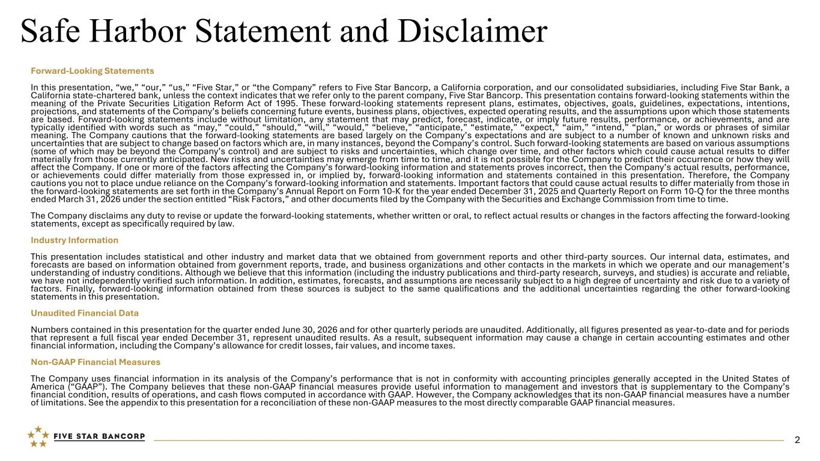
Safe Harbor Statement and Disclaimer Forward-Looking Statements In this presentation, “we,” “our,” “us,” “Five Star,” or “the Company” refers to Five Star Bancorp, a California corporation, and our consolidated subsidiaries, including Five Star Bank, a California state-chartered bank, unless the context indicates that we refer only to the parent company, Five Star Bancorp. This presentation contains forward-looking statements within the meaning of the Private Securities Litigation Reform Act of 1995. These forward-looking statements represent plans, estimates, objectives, goals, guidelines, expectations, intentions, projections, and statements of the Company’s beliefs concerning future events, business plans, objectives, expected operating results, and the assumptions upon which those statements are based. Forward-looking statements include without limitation, any statement that may predict, forecast, indicate, or imply future results, performance, or achievements, and are typically identified with words such as “may,” “could,” “should,” “will,” “would,” “believe,” “anticipate,” “estimate,” “expect,” “aim,” “intend,” “plan,” or words or phrases of similar meaning. The Company cautions that the forward-looking statements are based largely on the Company’s expectations and are subject to a number of known and unknown risks and uncertainties that are subject to change based on factors which are, in many instances, beyond the Company’s control. Such forward-looking statements are based on various assumptions (some of which may be beyond the Company’s control) and are subject to risks and uncertainties, which change over time, and other factors which could cause actual results to differ materially from those currently anticipated. New risks and uncertainties may emerge from time to time, and it is not possible for the Company to predict their occurrence or how they will affect the Company. If one or more of the factors affecting the Company’s forward-looking information and statements proves incorrect, then the Company’s actual results, performance, or achievements could differ materially from those expressed in, or implied by, forward-looking information and statements contained in this presentation. Therefore, the Company cautions you not to place undue reliance on the Company’s forward-looking information and statements. Important factors that could cause actual results to differ materially from those in the forward-looking statements are set forth in the Company’s Annual Report on Form 10-K for the year ended December 31, 2025 and Quarterly Report on Form 10-Q for the three months ended March 31, 2026 under the section entitled “Risk Factors,” and other documents filed by the Company with the Securities and Exchange Commission from time to time. The Company disclaims any duty to revise or update the forward-looking statements, whether written or oral, to reflect actual results or changes in the factors affecting the forward-looking statements, except as specifically required by law. Industry Information This presentation includes statistical and other industry and market data that we obtained from government reports and other third-party sources. Our internal data, estimates, and forecasts are based on information obtained from government reports, trade, and business organizations and other contacts in the markets in which we operate and our management’s understanding of industry conditions. Although we believe that this information (including the industry publications and third-party research, surveys, and studies) is accurate and reliable, we have not independently verified such information. In addition, estimates, forecasts, and assumptions are necessarily subject to a high degree of uncertainty and risk due to a variety of factors. Finally, forward-looking information obtained from these sources is subject to the same qualifications and the additional uncertainties regarding the other forward-looking statements in this presentation. Unaudited Financial Data Numbers contained in this presentation for the quarter ended June 30, 2026 and for other quarterly periods are unaudited. Additionally, all figures presented as year-to-date and for periods that represent a full fiscal year ended December 31, represent unaudited results. As a result, subsequent information may cause a change in certain accounting estimates and other financial information, including the Company’s allowance for credit losses, fair values, and income taxes. Non-GAAP Financial Measures The Company uses financial information in its analysis of the Company’s performance that is not in conformity with accounting principles generally accepted in the United States of America (“GAAP”). The Company believes that these non-GAAP financial measures provide useful information to management and investors that is supplementary to the Company’s financial condition, results of operations, and cash flows computed in accordance with GAAP. However, the Company acknowledges that its non-GAAP financial measures have a number of limitations. See the appendix to this presentation for a reconciliation of these non-GAAP measures to the most directly comparable GAAP financial measures. 2

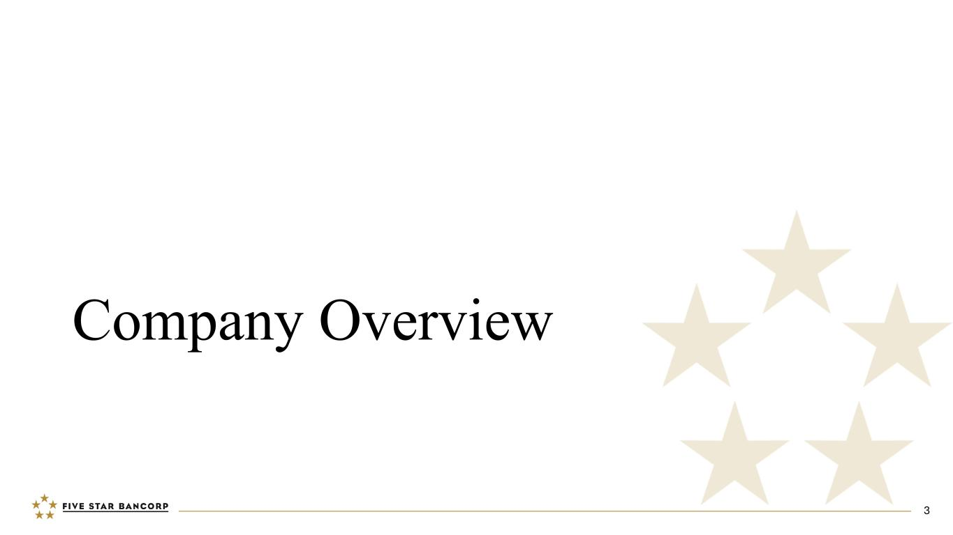
Company Overview 3

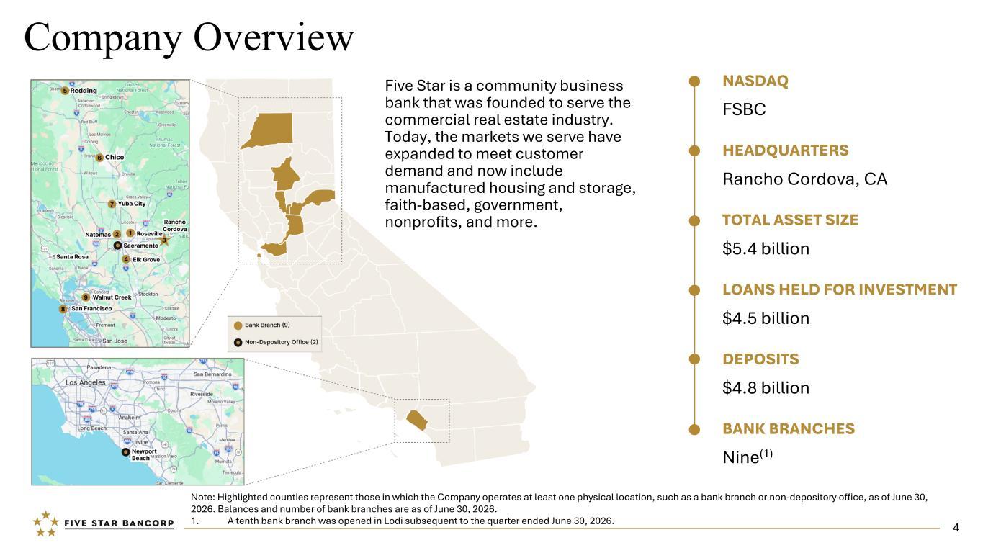
Company Overview NASDAQ FSBC HEADQUARTERS Rancho Cordova, CA TOTAL ASSET SIZE $5.4 billion LOANS HELD FOR INVESTMENT $4.5 billion DEPOSITS $4.8 billion BANK BRANCHES Nine(1) Note: Highlighted counties represent those in which the Company operates at least one physical location, such as a bank branch or non-depository office, as of June 30, 2026. Balances and number of bank branches are as of June 30, 2026. 1. A tenth bank branch was opened in Lodi subsequent to the quarter ended June 30, 2026. Five Star is a community business bank that was founded to serve the commercial real estate industry. Today, the markets we serve have expanded to meet customer demand and now include manufactured housing and storage, faith-based, government, nonprofits, and more. 4


Executive Team JAMES BECKWITH President Chief Executive Officer Five Star since 2003 JOHN DALTON Senior Vice President Chief Credit Officer Five Star since 2011 MIKE LEE Senior Vice President Chief Regulatory Officer Five Star since 2005 MICHAEL RIZZO Executive Vice President Chief Banking Officer Five Star since 2005 BRETT WAIT Senior Vice President Chief Information Officer Five Star since 2011 LYDIA RAMIREZ Executive Vice President Chief Operating Officer Five Star since 2017 HEATHER LUCK Executive Vice President Chief Financial Officer Five Star since 2018 SHELLEY WETTON Senior Vice President Chief Marketing Officer Five Star since 2015 DJ KURTZE Executive Vice President San Francisco Bay Area President Five Star since 2023 CLIFF COOPER Executive Vice President Food, Agribusiness and Diversified Industries President Five Star since 2025 5


Recent Awards and Rankings Five Star Bank Awards and Rankings S&P Global Market Intelligence 2025 | TOP 3 BEST-PERFORMING COMMUNITY BANKS IN THE NATION (Banks with $3B - $10B in Assets) 2025 | RAYMOND JAMES COMMUNITY BANKERS CUP (Ranked in Top 10% of Community Banks in the Nation) Bank Director Magazine (Ranking Banking) RANKED 4TH ON THE LIST OF THE BEST U.S. BANKS (Banks with Assets Less Than $5B) Bank Director Magazine (Ranking Banking) RANKED 13TH ON THE LIST OF TOP 25 U.S. BANKS Piper Sandler’s 2025 SM-ALL STARS Bank Executive and Employee Awards SACRAMENTO BUSINESS JOURNAL 40 Under 40 Power 100 List C-Suite Award Champions for DE&I Women Who Mean Business Fastest Growing Banks by Deposits SAN FRANCISCO BUSINESS TIMES 40 Under 40 Newsmaker 100 List Best Places to Work #1 Ranking SACRAMENTO METRO CHAMBER OF COMMERCE Sacramentan of the Year Award HISPANIC CHAMBER OF COMMERCE Champion Latina Estrella Award COMMERCIAL REAL ESTATE WOMEN SACRAMENTO Women of Impact Award SACRAMENTO STATE ALUMNI ASSOCIATION Distinguished Alumni Award 6

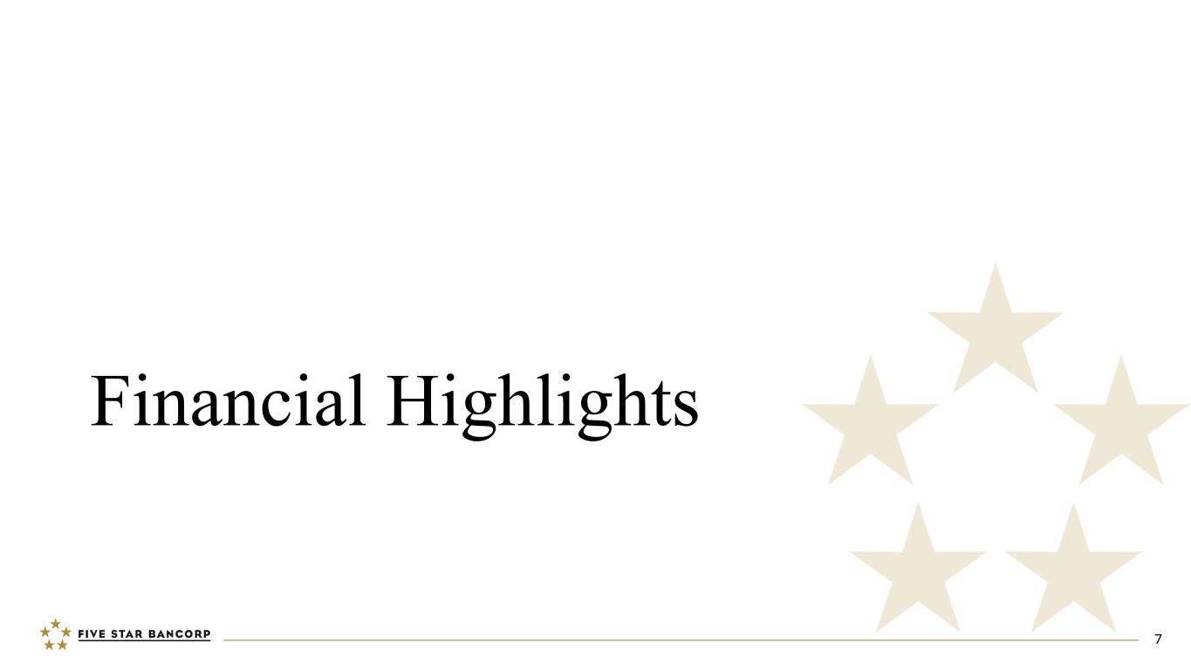
Financial Highlights 7

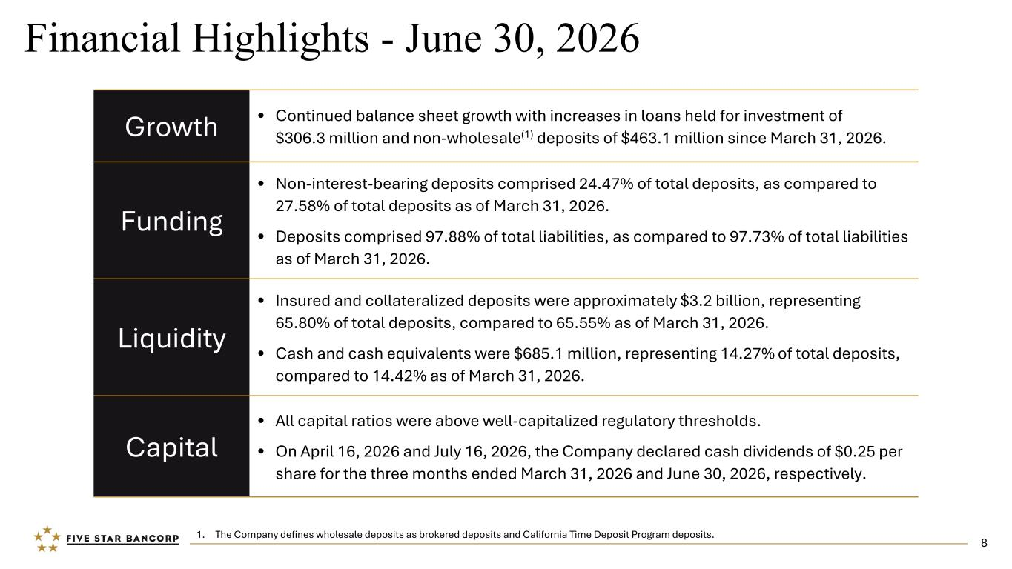
Growth • Continued balance sheet growth with increases in loans held for investment of $306.3 million and non-wholesale(1) deposits of $463.1 million since March 31, 2026. Funding • Non-interest-bearing deposits comprised 24.47% of total deposits, as compared to 27.58% of total deposits as of March 31, 2026. • Deposits comprised 97.88% of total liabilities, as compared to 97.73% of total liabilities as of March 31, 2026. Liquidity • Insured and collateralized deposits were approximately $3.2 billion, representing 65.80% of total deposits, compared to 65.55% as of March 31, 2026. • Cash and cash equivalents were $685.1 million, representing 14.27% of total deposits, compared to 14.42% as of March 31, 2026. Capital • All capital ratios were above well-capitalized regulatory thresholds. • On April 16, 2026 and July 16, 2026, the Company declared cash dividends of $0.25 per share for the three months ended March 31, 2026 and June 30, 2026, respectively. Financial Highlights - June 30, 2026 1. The Company defines wholesale deposits as brokered deposits and California Time Deposit Program deposits. 8

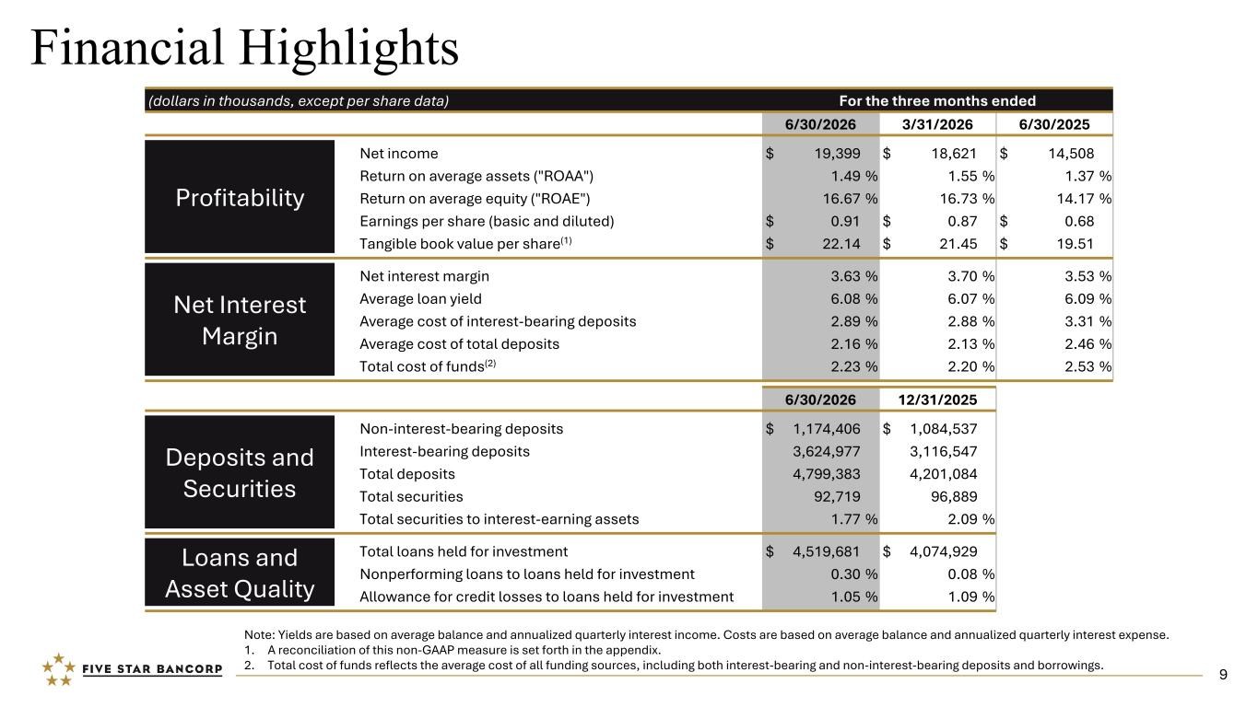
Financial Highlights (dollars in thousands, except per share data) For the three months ended 6/30/2026 3/31/2026 6/30/2025 Profitability Net income $ 19,399 $ 18,621 $ 14,508 Return on average assets ("ROAA") 1.49 % 1.55 % 1.37 % Return on average equity ("ROAE") 16.67 % 16.73 % 14.17 % Earnings per share (basic and diluted) $ 0.91 $ 0.87 $ 0.68 Tangible book value per share(1) $ 22.14 $ 21.45 $ 19.51 Net Interest Margin Net interest margin 3.63 % 3.70 % 3.53 % Average loan yield 6.08 % 6.07 % 6.09 % Average cost of interest-bearing deposits 2.89 % 2.88 % 3.31 % Average cost of total deposits 2.16 % 2.13 % 2.46 % Total cost of funds(2) 2.23 % 2.20 % 2.53 % 6/30/2026 12/31/2025 Deposits and Securities Non-interest-bearing deposits $ 1,174,406 $ 1,084,537 Interest-bearing deposits 3,624,977 3,116,547 Total deposits 4,799,383 4,201,084 Total securities 92,719 96,889 Total securities to interest-earning assets 1.77 % 2.09 % Loans and Asset Quality Total loans held for investment $ 4,519,681 $ 4,074,929 Nonperforming loans to loans held for investment 0.30 % 0.08 % Allowance for credit losses to loans held for investment 1.05 % 1.09 % Note: Yields are based on average balance and annualized quarterly interest income. Costs are based on average balance and annualized quarterly interest expense. 1. A reconciliation of this non-GAAP measure is set forth in the appendix. 2. Total cost of funds reflects the average cost of all funding sources, including both interest-bearing and non-interest-bearing deposits and borrowings. 9

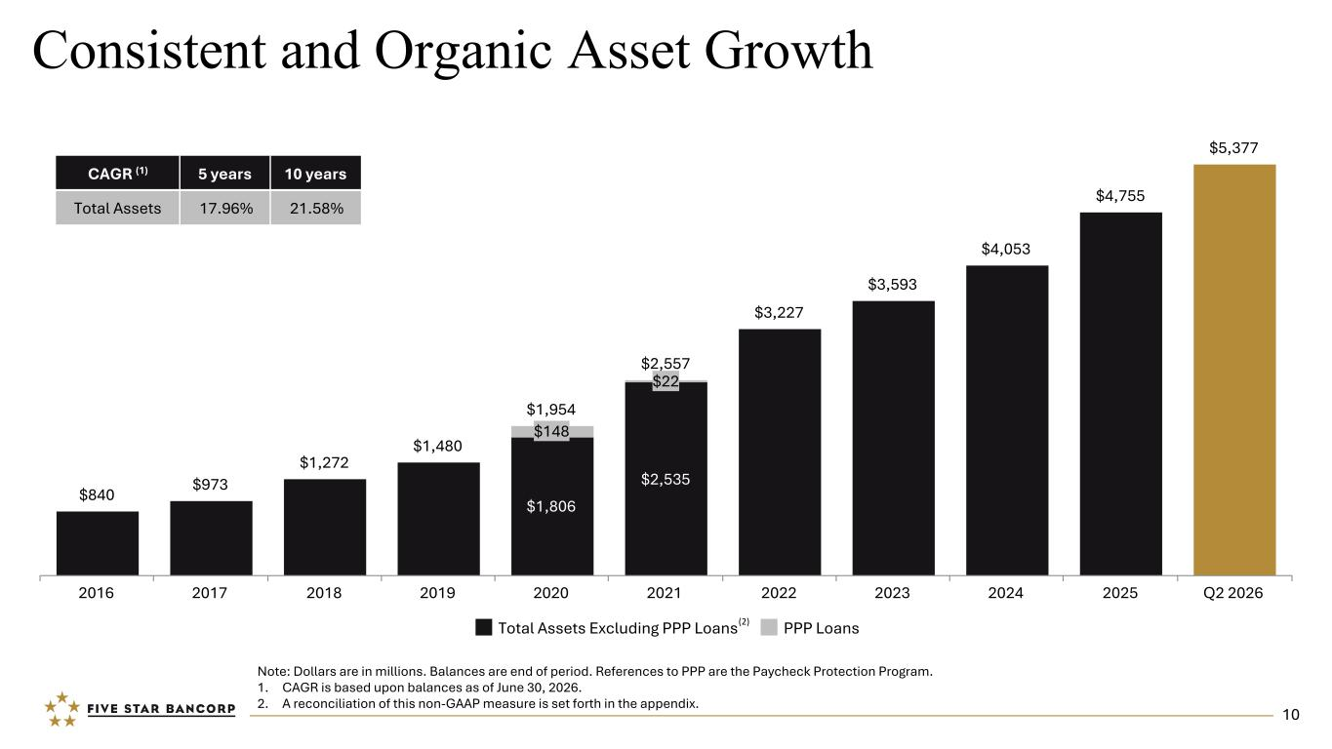
$840 $973 $1,272 $1,480 $1,954 $2,557 $3,227 $3,593 $4,053 $4,755 $5,377 $1,806 $2,535 $148 $22 Total Assets Excluding PPP Loans PPP Loans 2016 2017 2018 2019 2020 2021 2022 2023 2024 2025 Q2 2026 Consistent and Organic Asset Growth Note: Dollars are in millions. Balances are end of period. References to PPP are the Paycheck Protection Program. 1. CAGR is based upon balances as of June 30, 2026. 2. A reconciliation of this non-GAAP measure is set forth in the appendix. (2) CAGR (1) 5 years 10 years Total Assets 17.96% 21.58% 10

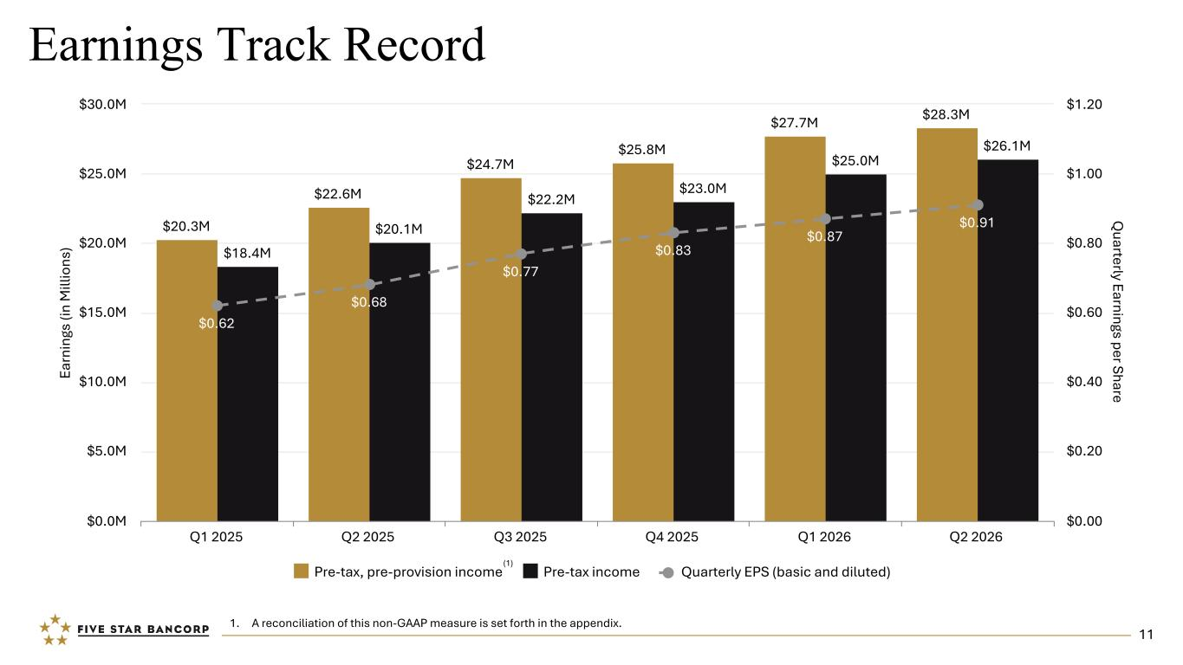
Earnings Track Record Ea rn in gs (i n M ill io ns ) Q uarterly Earnings per Share $20.3M $22.6M $24.7M $25.8M $27.7M $28.3M $18.4M $20.1M $22.2M $23.0M $25.0M $26.1M $0.62 $0.68 $0.77 $0.83 $0.87 $0.91 Pre-tax, pre-provision income Pre-tax income Quarterly EPS (basic and diluted) Q1 2025 Q2 2025 Q3 2025 Q4 2025 Q1 2026 Q2 2026 $0.0M $5.0M $10.0M $15.0M $20.0M $25.0M $30.0M $0.00 $0.20 $0.40 $0.60 $0.80 $1.00 $1.20 1. A reconciliation of this non-GAAP measure is set forth in the appendix. (1) 11

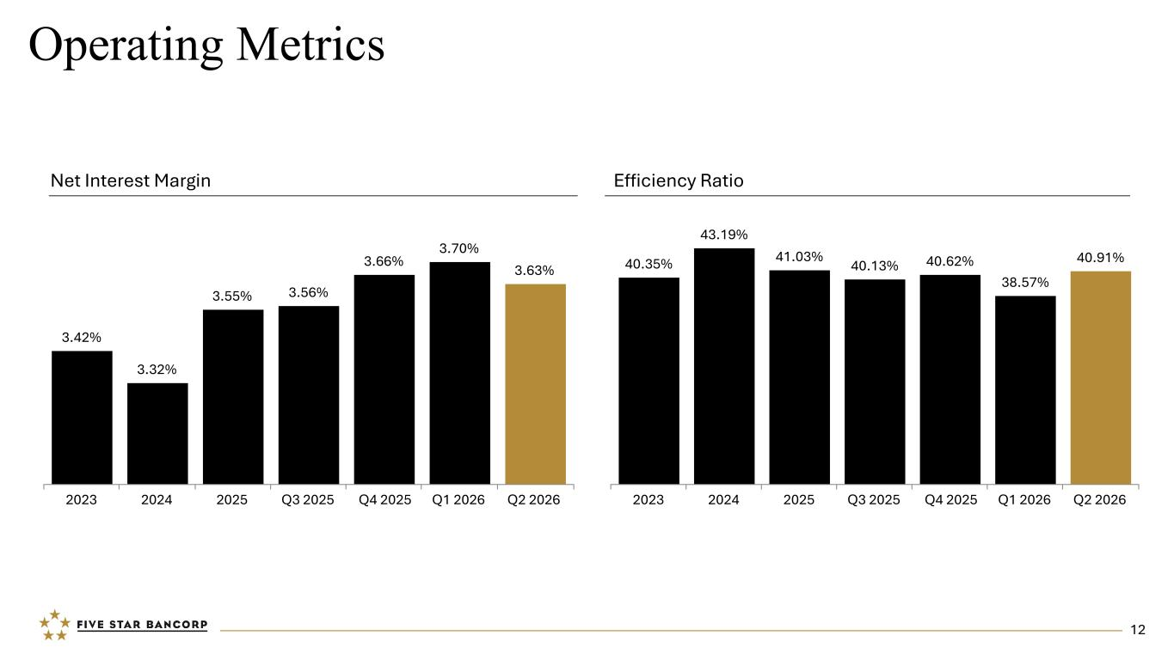
Operating Metrics Efficiency RatioNet Interest Margin 3.42% 3.32% 3.55% 3.56% 3.66% 3.70% 3.63% 2023 2024 2025 Q3 2025 Q4 2025 Q1 2026 Q2 2026 40.35% 43.19% 41.03% 40.13% 40.62% 38.57% 40.91% 2023 2024 2025 Q3 2025 Q4 2025 Q1 2026 Q2 2026 12

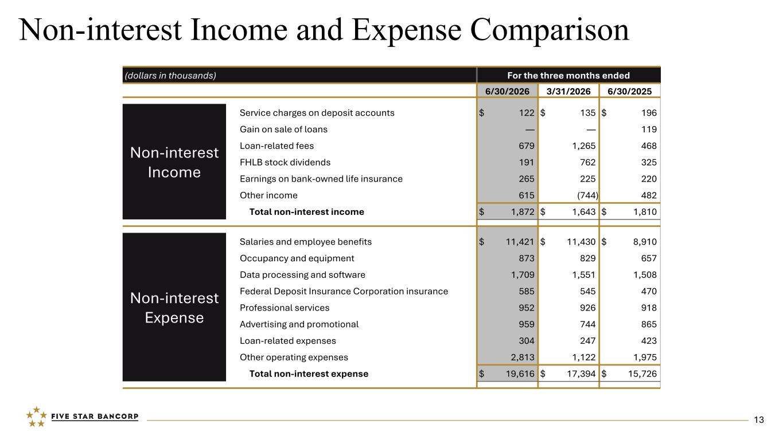
Non-interest Income and Expense Comparison (dollars in thousands) For the three months ended 6/30/2026 3/31/2026 6/30/2025 Non-interest Income Service charges on deposit accounts $ 122 $ 135 $ 196 Gain on sale of loans — — 119 Loan-related fees 679 1,265 468 FHLB stock dividends 191 762 325 Earnings on bank-owned life insurance 265 225 220 Other income 615 (744) 482 Total non-interest income $ 1,872 $ 1,643 $ 1,810 Non-interest Expense Salaries and employee benefits $ 11,421 $ 11,430 $ 8,910 Occupancy and equipment 873 829 657 Data processing and software 1,709 1,551 1,508 Federal Deposit Insurance Corporation insurance 585 545 470 Professional services 952 926 918 Advertising and promotional 959 744 865 Loan-related expenses 304 247 423 Other operating expenses 2,813 1,122 1,975 Total non-interest expense $ 19,616 $ 17,394 $ 15,726 13

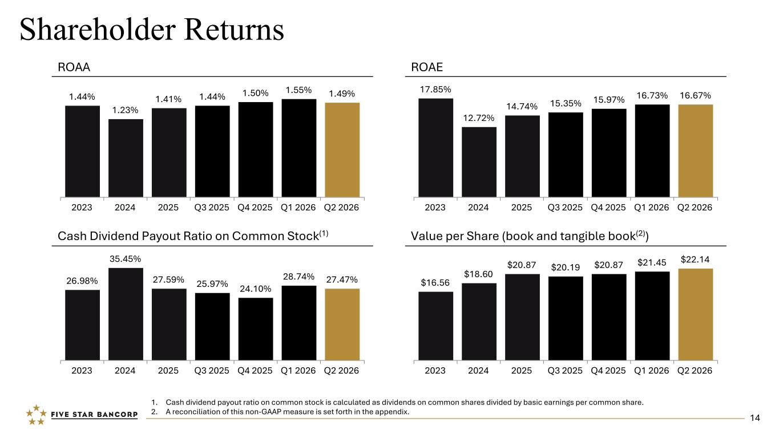
Shareholder Returns ROAA ROAE Value per Share (book and tangible book(2)) 1. Cash dividend payout ratio on common stock is calculated as dividends on common shares divided by basic earnings per common share. 2. A reconciliation of this non-GAAP measure is set forth in the appendix. 1.44% 1.23% 1.41% 1.44% 1.50% 1.55% 1.49% 2023 2024 2025 Q3 2025 Q4 2025 Q1 2026 Q2 2026 17.85% 12.72% 14.74% 15.35% 15.97% 16.73% 16.67% 2023 2024 2025 Q3 2025 Q4 2025 Q1 2026 Q2 2026 $16.56 $18.60 $20.87 $20.19 $20.87 $21.45 $22.14 2023 2024 2025 Q3 2025 Q4 2025 Q1 2026 Q2 2026 26.98% 35.45% 27.59% 25.97% 24.10% 28.74% 27.47% 2023 2024 2025 Q3 2025 Q4 2025 Q1 2026 Q2 2026 14 Cash Dividend Payout Ratio on Common Stock(1)

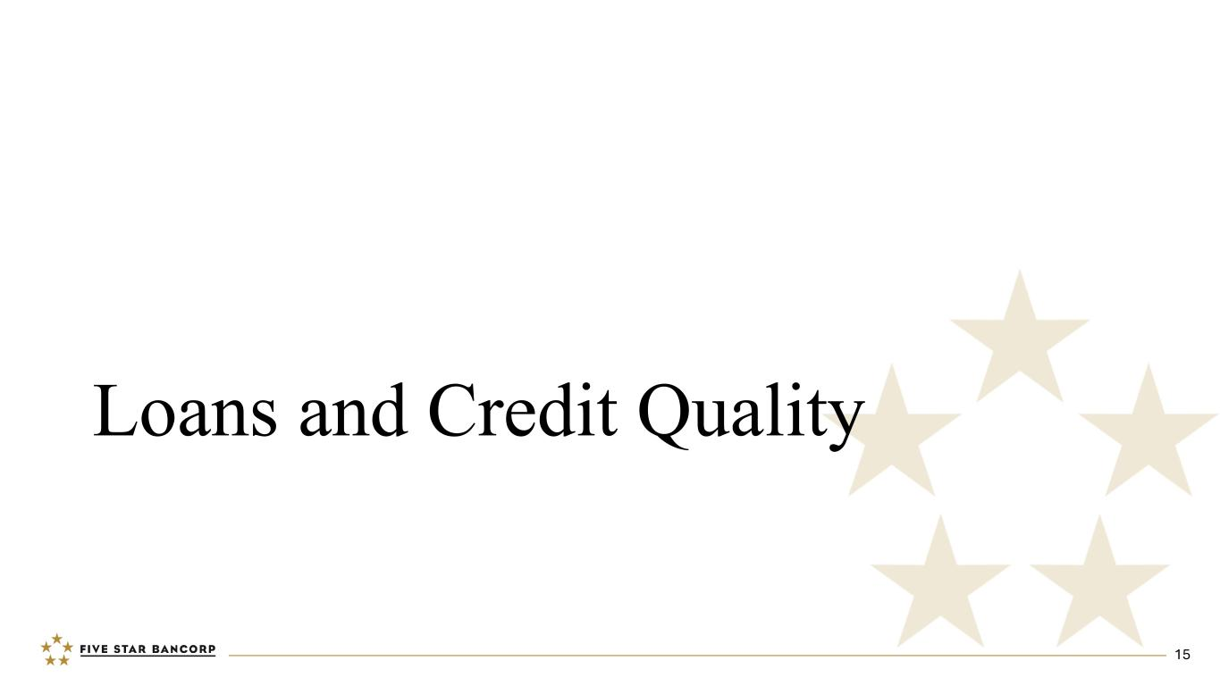
Loans and Credit Quality 15

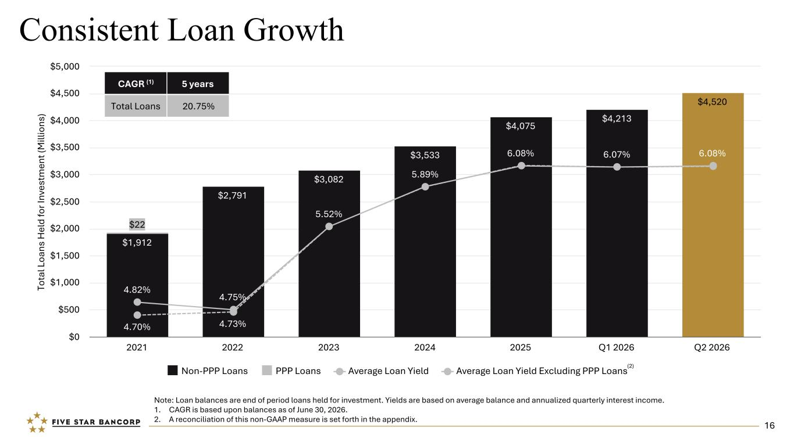
To ta l L oa ns H el d fo r I nv es tm en t ( M ill io ns ) $1,912 $2,791 $3,082 $3,533 $4,075 $4,213 $4,520 $22 4.82% 4.75% 5.52% 5.89% 6.08% 6.07% 6.08% 4.70% 4.73% Non-PPP Loans PPP Loans Average Loan Yield Average Loan Yield Excluding PPP Loans 2021 2022 2023 2024 2025 Q1 2026 Q2 2026 $0 $500 $1,000 $1,500 $2,000 $2,500 $3,000 $3,500 $4,000 $4,500 $5,000 Consistent Loan Growth Note: Loan balances are end of period loans held for investment. Yields are based on average balance and annualized quarterly interest income. 1. CAGR is based upon balances as of June 30, 2026. 2. A reconciliation of this non-GAAP measure is set forth in the appendix. (2) CAGR (1) 5 years Total Loans 20.75% 16

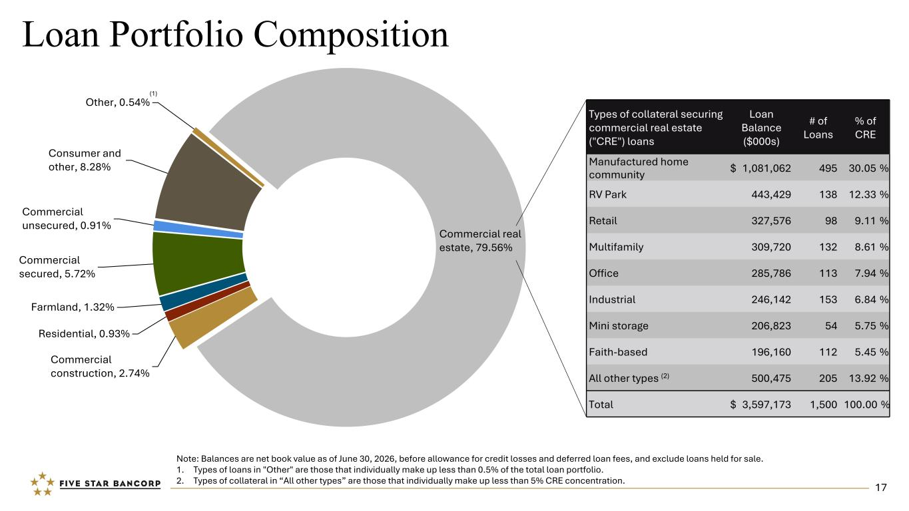
Commercial real estate, 79.56% Commercial construction, 2.74% Residential, 0.93% Farmland, 1.32% Commercial secured, 5.72% Commercial unsecured, 0.91% Consumer and other, 8.28% Other, 0.54% Loan Portfolio Composition Types of collateral securing commercial real estate ("CRE") loans Loan Balance ($000s) # of Loans % of CRE Manufactured home community $ 1,081,062 495 30.05 % RV Park 443,429 138 12.33 % Retail 327,576 98 9.11 % Multifamily 309,720 132 8.61 % Office 285,786 113 7.94 % Industrial 246,142 153 6.84 % Mini storage 206,823 54 5.75 % Faith-based 196,160 112 5.45 % All other types (2) 500,475 205 13.92 % Total $ 3,597,173 1,500 100.00 % Note: Balances are net book value as of June 30, 2026, before allowance for credit losses and deferred loan fees, and exclude loans held for sale. 1. Types of loans in "Other" are those that individually make up less than 0.5% of the total loan portfolio. 2. Types of collateral in “All other types” are those that individually make up less than 5% CRE concentration. (1) 17

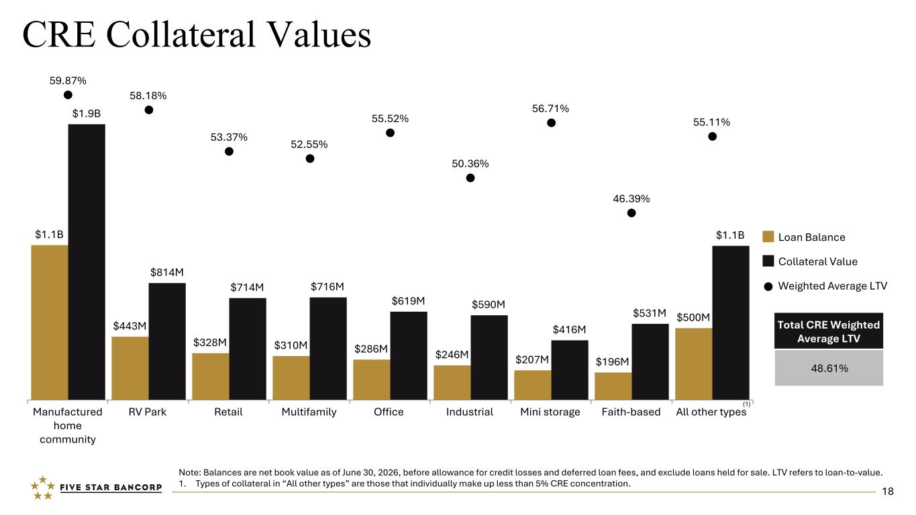
$1.1B $443M $328M $310M $286M $246M $207M $196M $500M $1.9B $814M $714M $716M $619M $590M $416M $531M $1.1B 59.87% 58.18% 53.37% 52.55% 55.52% 50.36% 56.71% 46.39% 55.11% Loan Balance Collateral Value Weighted Average LTV Manufactured home community RV Park Retail Multifamily Office Industrial Mini storage Faith-based All other types CRE Collateral Values (1) Note: Balances are net book value as of June 30, 2026, before allowance for credit losses and deferred loan fees, and exclude loans held for sale. LTV refers to loan-to-value. 1. Types of collateral in “All other types” are those that individually make up less than 5% CRE concentration. Total CRE Weighted Average LTV 48.61% 18

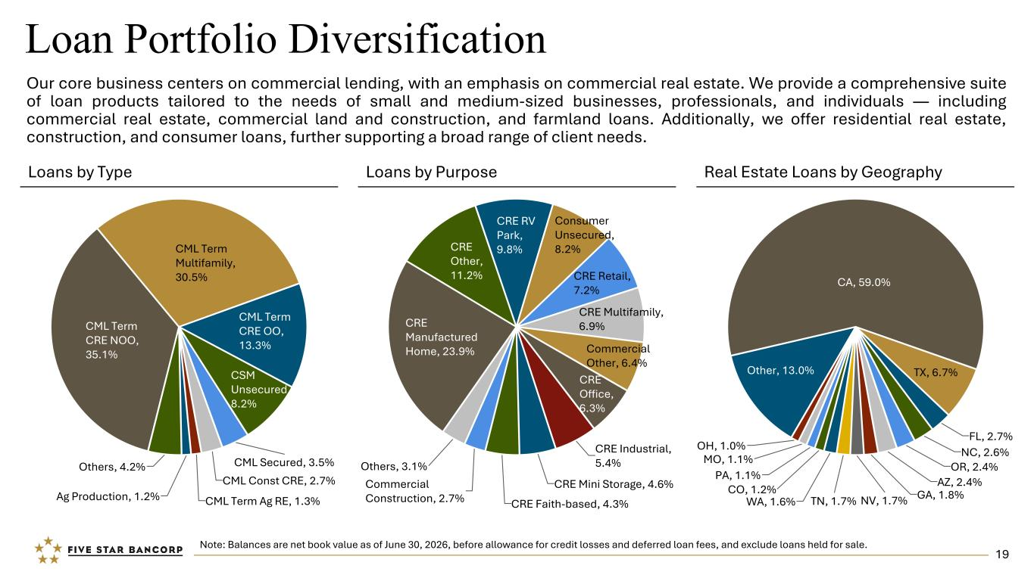
CA, 59.0% TX, 6.7% FL, 2.7% NC, 2.6% OR, 2.4% AZ, 2.4% GA, 1.8%NV, 1.7%TN, 1.7%WA, 1.6% CO, 1.2% PA, 1.1% MO, 1.1% OH, 1.0% Other, 13.0% CML Term CRE NOO, 35.1% CML Term Multifamily, 30.5% CML Term CRE OO, 13.3% CSM Unsecured, 8.2% CML Secured, 3.5% CML Const CRE, 2.7% CML Term Ag RE, 1.3%Ag Production, 1.2% Others, 4.2% CRE Manufactured Home, 23.9% CRE Other, 11.2% CRE RV Park, 9.8% Consumer Unsecured, 8.2% CRE Retail, 7.2% CRE Multifamily, 6.9% Commercial Other, 6.4% CRE Office, 6.3% CRE Industrial, 5.4% CRE Mini Storage, 4.6% CRE Faith-based, 4.3% Commercial Construction, 2.7% Others, 3.1% Loan Portfolio Diversification Our core business centers on commercial lending, with an emphasis on commercial real estate. We provide a comprehensive suite of loan products tailored to the needs of small and medium-sized businesses, professionals, and individuals — including commercial real estate, commercial land and construction, and farmland loans. Additionally, we offer residential real estate, construction, and consumer loans, further supporting a broad range of client needs. Note: Balances are net book value as of June 30, 2026, before allowance for credit losses and deferred loan fees, and exclude loans held for sale. Loans by Type Loans by Purpose Real Estate Loans by Geography 19

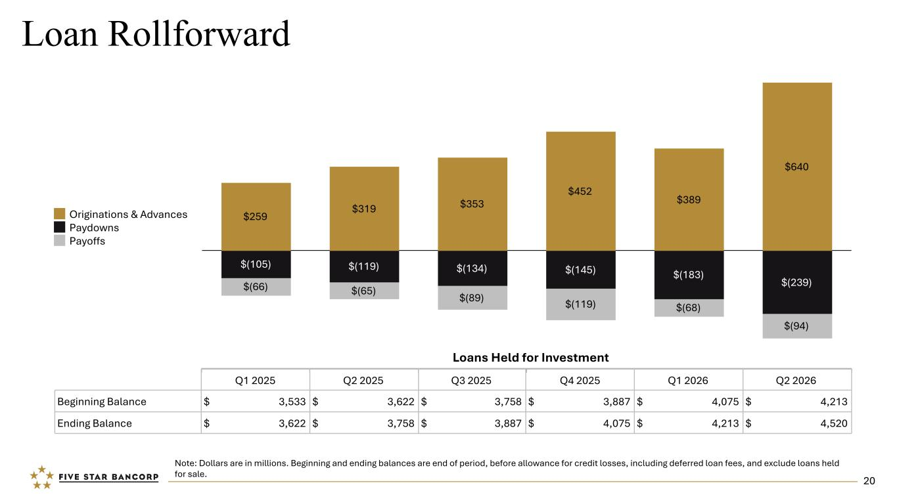
Loan Rollforward Note: Dollars are in millions. Beginning and ending balances are end of period, before allowance for credit losses, including deferred loan fees, and exclude loans held for sale. $259 $319 $353 $452 $389 $640 $(105) $(119) $(134) $(145) $(183) $(239)$(66) $(65) $(89) $(119) $(68) $(94) Originations & Advances Paydowns Payoffs Q1 2025 Q2 2025 Q3 2025 Q4 2025 Q1 2026 Q2 2026 Beginning Balance $ 3,533 $ 3,622 $ 3,758 $ 3,887 $ 4,075 $ 4,213 Ending Balance $ 3,622 $ 3,758 $ 3,887 $ 4,075 $ 4,213 $ 4,520 Loans Held for Investment 20

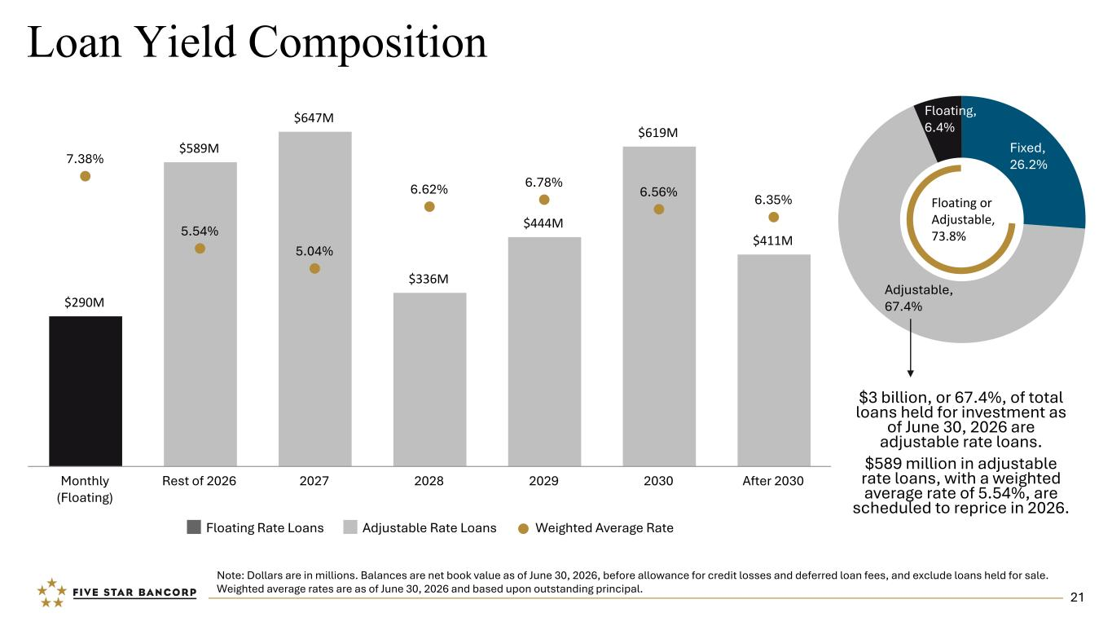
Loan Yield Composition Note: Dollars are in millions. Balances are net book value as of June 30, 2026, before allowance for credit losses and deferred loan fees, and exclude loans held for sale. Weighted average rates are as of June 30, 2026 and based upon outstanding principal. Fixed, 26.2% Adjustable, 67.4% Floating, 6.4% Floating or Adjustable, 73.8% $290M $589M $647M $336M $444M $619M $411M 7.38% 5.54% 5.04% 6.62% 6.78% 6.56% 6.35% Floating Rate Loans Adjustable Rate Loans Weighted Average Rate Monthly (Floating) Rest of 2026 2027 2028 2029 2030 After 2030 $3 billion, or 67.4%, of total loans held for investment as of June 30, 2026 are adjustable rate loans. $589 million in adjustable rate loans, with a weighted average rate of 5.54%, are scheduled to reprice in 2026. 21

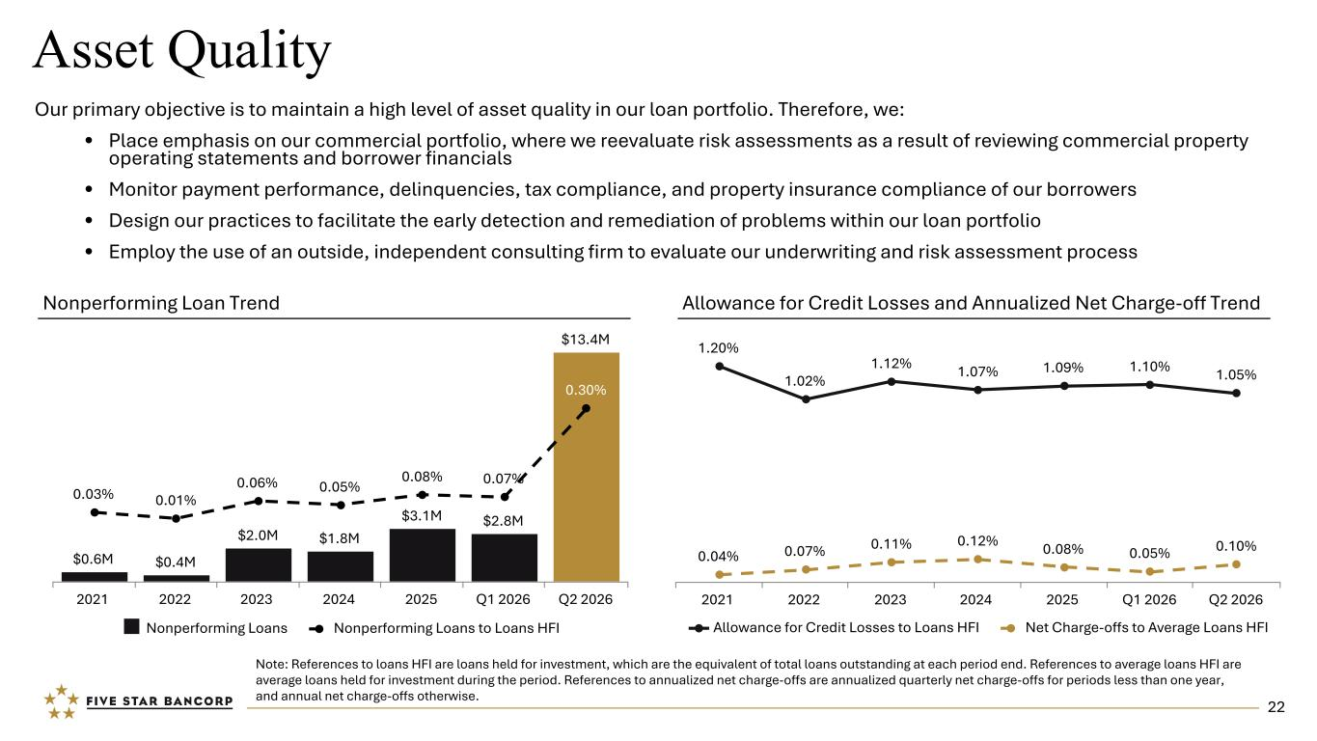
1.20% 1.02% 1.12% 1.07% 1.09% 1.10% 1.05% 0.04% 0.07% 0.11% 0.12% 0.08% 0.05% 0.10% Allowance for Credit Losses to Loans HFI Net Charge-offs to Average Loans HFI 2021 2022 2023 2024 2025 Q1 2026 Q2 2026 Asset Quality Nonperforming Loan Trend Allowance for Credit Losses and Annualized Net Charge-off Trend Note: References to loans HFI are loans held for investment, which are the equivalent of total loans outstanding at each period end. References to average loans HFI are average loans held for investment during the period. References to annualized net charge-offs are annualized quarterly net charge-offs for periods less than one year, and annual net charge-offs otherwise. $0.6M $0.4M $2.0M $1.8M $3.1M $2.8M $13.4M 0.03% 0.01% 0.06% 0.05% 0.08% 0.07% 0.30% Nonperforming Loans Nonperforming Loans to Loans HFI 2021 2022 2023 2024 2025 Q1 2026 Q2 2026 Our primary objective is to maintain a high level of asset quality in our loan portfolio. Therefore, we: • Place emphasis on our commercial portfolio, where we reevaluate risk assessments as a result of reviewing commercial property operating statements and borrower financials • Monitor payment performance, delinquencies, tax compliance, and property insurance compliance of our borrowers • Design our practices to facilitate the early detection and remediation of problems within our loan portfolio • Employ the use of an outside, independent consulting firm to evaluate our underwriting and risk assessment process 22

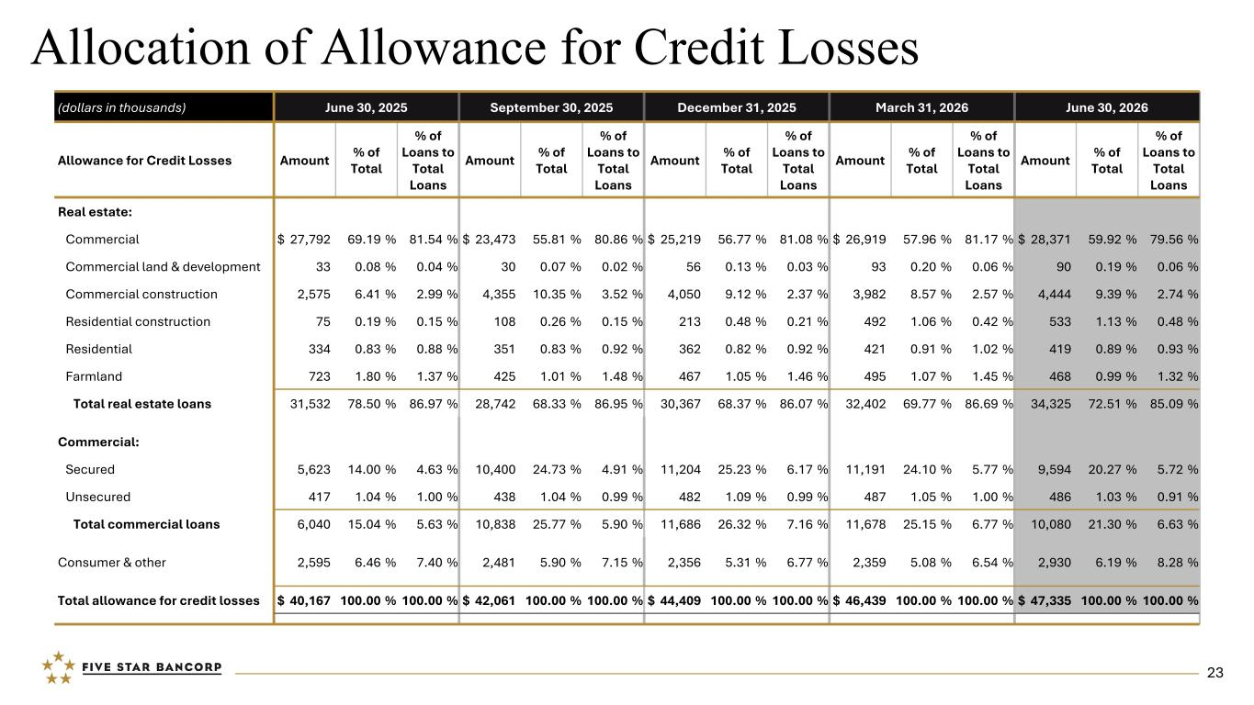
Allocation of Allowance for Credit Losses (dollars in thousands) June 30, 2025 September 30, 2025 December 31, 2025 March 31, 2026 June 30, 2026 Allowance for Credit Losses Amount % of Total % of Loans to Total Loans Amount % of Total % of Loans to Total Loans Amount % of Total % of Loans to Total Loans Amount % of Total % of Loans to Total Loans Amount % of Total % of Loans to Total Loans Real estate: Commercial $ 27,792 69.19 % 81.54 % $ 23,473 55.81 % 80.86 % $ 25,219 56.77 % 81.08 % $ 26,919 57.96 % 81.17 % $ 28,371 59.92 % 79.56 % Commercial land & development 33 0.08 % 0.04 % 30 0.07 % 0.02 % 56 0.13 % 0.03 % 93 0.20 % 0.06 % 90 0.19 % 0.06 % Commercial construction 2,575 6.41 % 2.99 % 4,355 10.35 % 3.52 % 4,050 9.12 % 2.37 % 3,982 8.57 % 2.57 % 4,444 9.39 % 2.74 % Residential construction 75 0.19 % 0.15 % 108 0.26 % 0.15 % 213 0.48 % 0.21 % 492 1.06 % 0.42 % 533 1.13 % 0.48 % Residential 334 0.83 % 0.88 % 351 0.83 % 0.92 % 362 0.82 % 0.92 % 421 0.91 % 1.02 % 419 0.89 % 0.93 % Farmland 723 1.80 % 1.37 % 425 1.01 % 1.48 % 467 1.05 % 1.46 % 495 1.07 % 1.45 % 468 0.99 % 1.32 % Total real estate loans 31,532 78.50 % 86.97 % 28,742 68.33 % 86.95 % 30,367 68.37 % 86.07 % 32,402 69.77 % 86.69 % 34,325 72.51 % 85.09 % Commercial: Secured 5,623 14.00 % 4.63 % 10,400 24.73 % 4.91 % 11,204 25.23 % 6.17 % 11,191 24.10 % 5.77 % 9,594 20.27 % 5.72 % Unsecured 417 1.04 % 1.00 % 438 1.04 % 0.99 % 482 1.09 % 0.99 % 487 1.05 % 1.00 % 486 1.03 % 0.91 % Total commercial loans 6,040 15.04 % 5.63 % 10,838 25.77 % 5.90 % 11,686 26.32 % 7.16 % 11,678 25.15 % 6.77 % 10,080 21.30 % 6.63 % Consumer & other 2,595 6.46 % 7.40 % 2,481 5.90 % 7.15 % 2,356 5.31 % 6.77 % 2,359 5.08 % 6.54 % 2,930 6.19 % 8.28 % Total allowance for credit losses $ 40,167 100.00 % 100.00 % $ 42,061 100.00 % 100.00 % $ 44,409 100.00 % 100.00 % $ 46,439 100.00 % 100.00 % $ 47,335 100.00 % 100.00 % 23

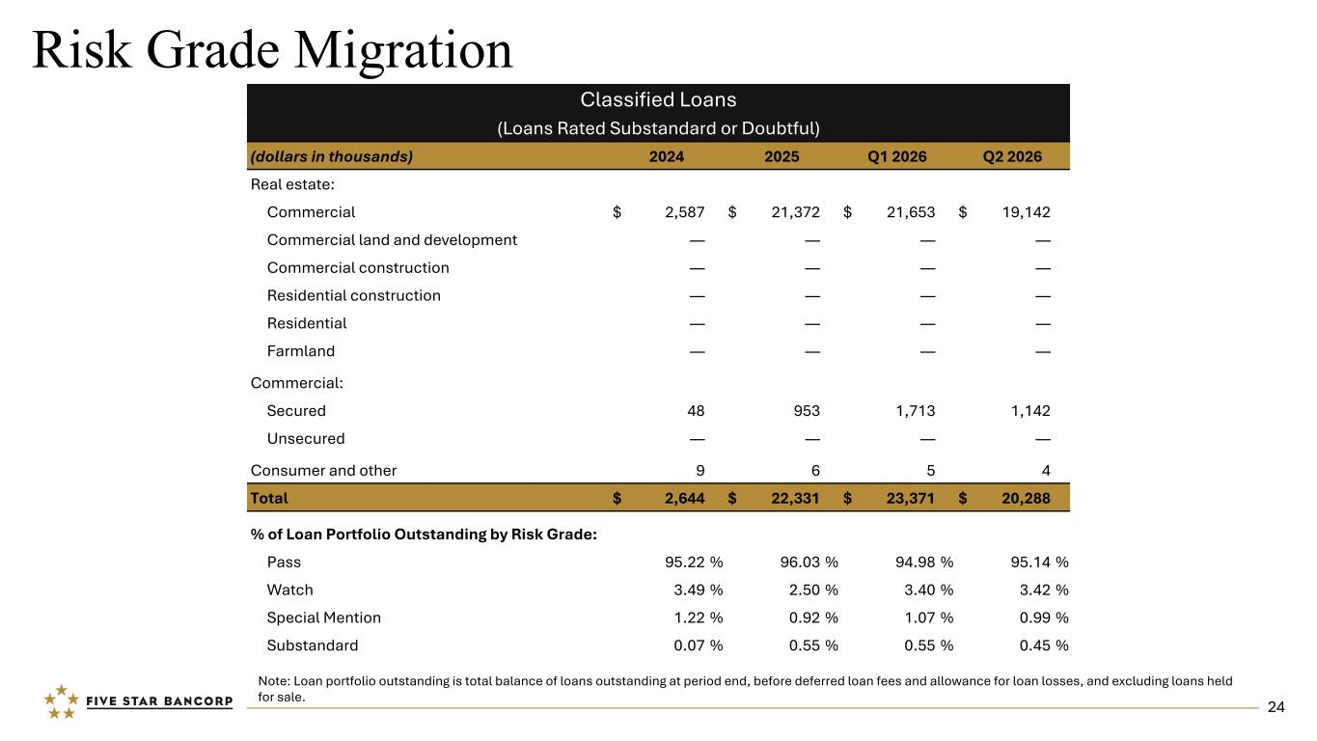
Risk Grade Migration Classified Loans (Loans Rated Substandard or Doubtful) (dollars in thousands) 2024 2025 Q1 2026 Q2 2026 Real estate: Commercial $ 2,587 $ 21,372 $ 21,653 $ 19,142 Commercial land and development — — — — Commercial construction — — — — Residential construction — — — — Residential — — — — Farmland — — — — Commercial: Secured 48 953 1,713 1,142 Unsecured — — — — Consumer and other 9 6 5 4 Total $ 2,644 $ 22,331 $ 23,371 $ 20,288 % of Loan Portfolio Outstanding by Risk Grade: Pass 95.22 % 96.03 % 94.98 % 95.14 % Watch 3.49 % 2.50 % 3.40 % 3.42 % Special Mention 1.22 % 0.92 % 1.07 % 0.99 % Substandard 0.07 % 0.55 % 0.55 % 0.45 % Note: Loan portfolio outstanding is total balance of loans outstanding at period end, before deferred loan fees and allowance for loan losses, and excluding loans held for sale. 24

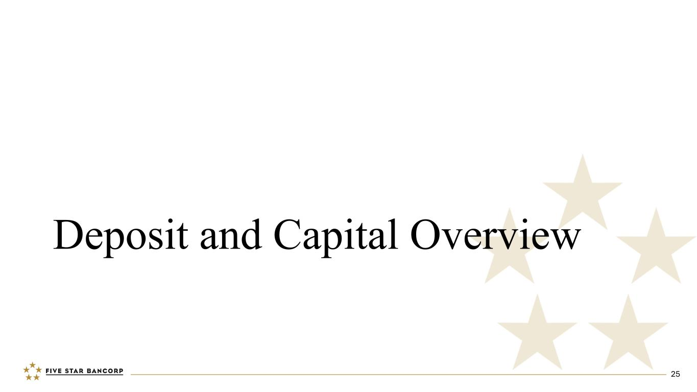
Deposit and Capital Overview 25

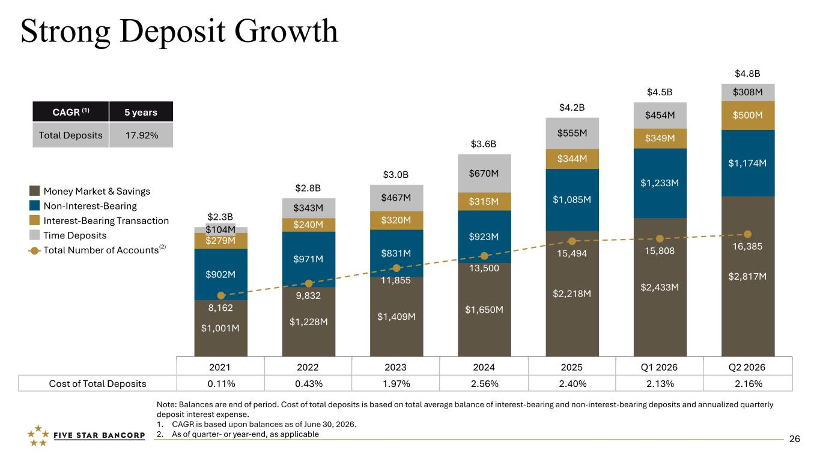
$2.3B $2.8B $3.0B $3.6B $4.2B $4.5B $4.8B $1,001M $1,228M $1,409M $1,650M $2,218M $2,433M $2,817M$902M $971M $831M $923M $1,085M $1,233M $1,174M $279M $240M $320M $315M $344M $349M $500M $104M $343M $467M $670M $555M $454M $308M 8,162 9,832 11,855 13,500 15,494 15,808 16,385 Money Market & Savings Non-Interest-Bearing Interest-Bearing Transaction Time Deposits Total Number of Accounts 2021 2022 2023 2024 2025 Q1 2026 Q2 2026 Strong Deposit Growth Note: Balances are end of period. Cost of total deposits is based on total average balance of interest-bearing and non-interest-bearing deposits and annualized quarterly deposit interest expense. 1. CAGR is based upon balances as of June 30, 2026. 2. As of quarter- or year-end, as applicable Cost of Total Deposits 0.11% 0.43% 1.97% 2.56% 2.40% 2.13% 2.16% CAGR (1) 5 years Total Deposits 17.92% (2) 26

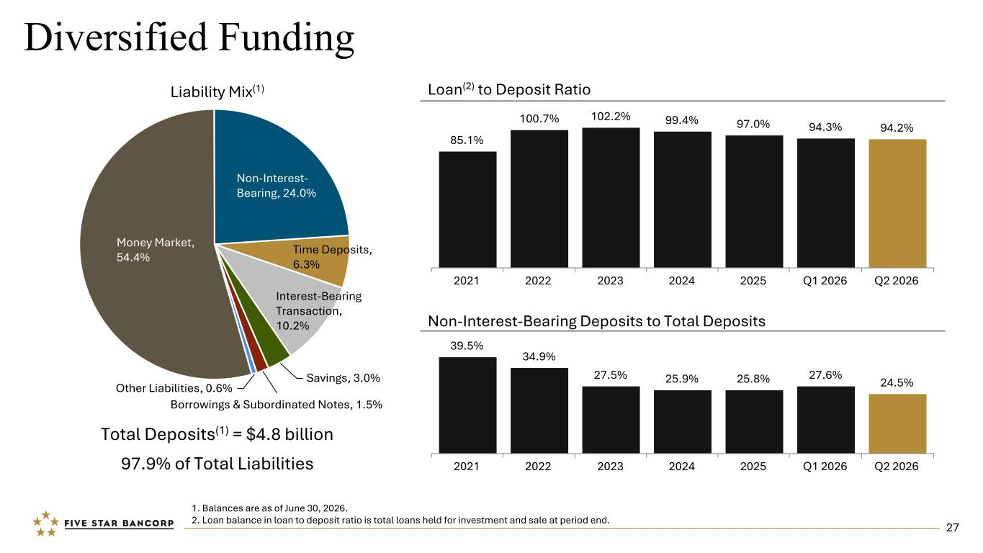
Diversified Funding Total Deposits(1) = $4.8 billion 97.9% of Total Liabilities Liability Mix(1) 1. Balances are as of June 30, 2026. 2. Loan balance in loan to deposit ratio is total loans held for investment and sale at period end. Loan(2) to Deposit Ratio Non-Interest-Bearing Deposits to Total Deposits 85.1% 100.7% 102.2% 99.4% 97.0% 94.3% 94.2% 2021 2022 2023 2024 2025 Q1 2026 Q2 2026 39.5% 34.9% 27.5% 25.9% 25.8% 27.6% 24.5% 2021 2022 2023 2024 2025 Q1 2026 Q2 2026 Money Market, 54.4% Non-Interest- Bearing, 24.0% Time Deposits, 6.3% Interest-Bearing Transaction, 10.2% Savings, 3.0% Borrowings & Subordinated Notes, 1.5% Other Liabilities, 0.6% 27

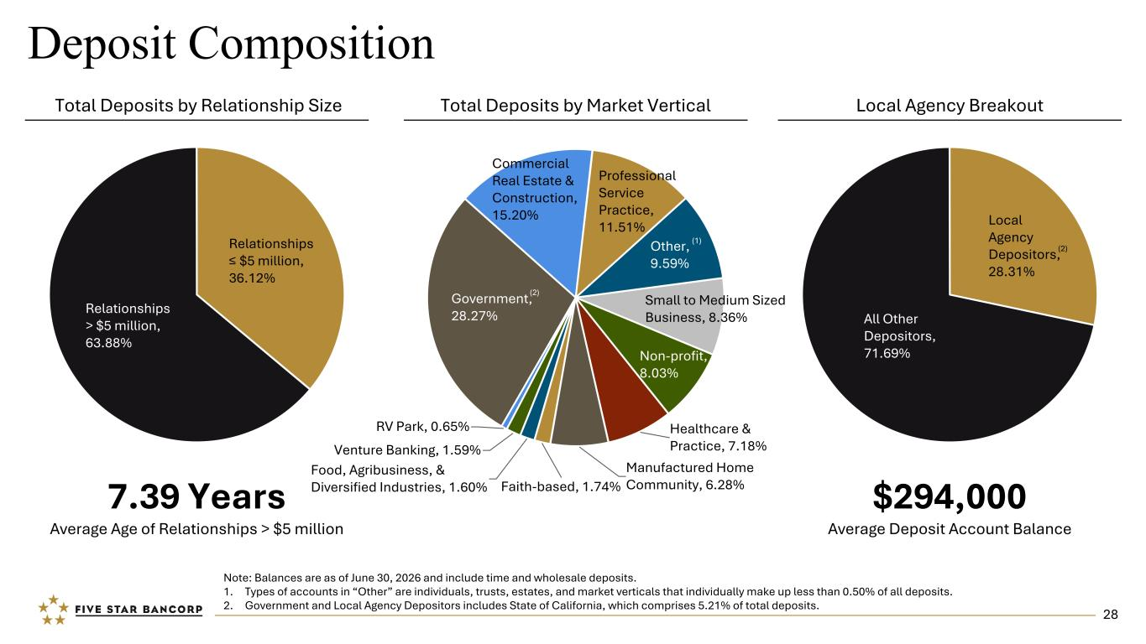
Government, 28.27% Commercial Real Estate & Construction, 15.20% Professional Service Practice, 11.51% Other, 9.59% Small to Medium Sized Business, 8.36% Non-profit, 8.03% Healthcare & Practice, 7.18% Manufactured Home Community, 6.28%Faith-based, 1.74% Food, Agribusiness, & Diversified Industries, 1.60% Venture Banking, 1.59% RV Park, 0.65% Deposit Composition 7.39 Years Average Age of Relationships > $5 million Note: Balances are as of June 30, 2026 and include time and wholesale deposits. 1. Types of accounts in “Other” are individuals, trusts, estates, and market verticals that individually make up less than 0.50% of all deposits. 2. Government and Local Agency Depositors includes State of California, which comprises 5.21% of total deposits. $294,000 Average Deposit Account Balance Relationships > $5 million, 63.88% Relationships ≤ $5 million, 36.12% Total Deposits by Relationship Size Local Agency BreakoutTotal Deposits by Market Vertical Local Agency Depositors, 28.31% All Other Depositors, 71.69% (2) (1) (2) 28

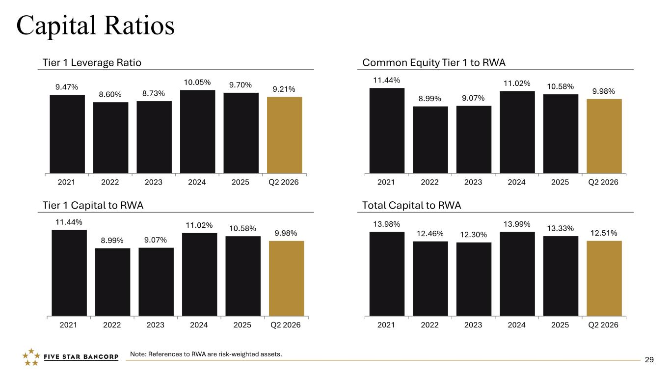
Capital Ratios Tier 1 Leverage Ratio Tier 1 Capital to RWA Total Capital to RWA Common Equity Tier 1 to RWA Note: References to RWA are risk-weighted assets. 9.47% 8.60% 8.73% 10.05% 9.70% 9.21% 2021 2022 2023 2024 2025 Q2 2026 11.44% 8.99% 9.07% 11.02% 10.58% 9.98% 2021 2022 2023 2024 2025 Q2 2026 11.44% 8.99% 9.07% 11.02% 10.58% 9.98% 2021 2022 2023 2024 2025 Q2 2026 13.98% 12.46% 12.30% 13.99% 13.33% 12.51% 2021 2022 2023 2024 2025 Q2 2026 29


“Five Star Bank customer, Visit Sacramento, ensures our region is a leading destination for meetings, conventions, travel trade and leisure, which support the vitality of our regional economy by driving almost $200 million in visitor spending annually. Their vision is for every person in the world to say, “I want to visit Sacramento!” David Eadie, Chief Sports & Entertainment Officer Sonya Bradley, Chief DEI & Community Relations Officer Mariles Krock, Chief Convention Sales & Services Officer Kari Miskit, Chief Operating Officer & Media Relations Mike Testa, President & CEO VISIT SACRAMENTO Five Star Bank customer, Cristo Rey High School Sacramento, is a Catholic, fully-accredited college preparatory high school. They offer a focused curriculum designed to support students not only in being accepted to college, but in graduating from college. Their goal is to educate the “whole person,” that is the mind, body and spirit of each student. They offer a challenging academic curriculum, as well as opportunities for co-curricular, spiritual and religious formation. Dave Lucchetti, Five Star Bancorp Retired Board Chair Father Christopher Calderon, President Cristo Rey Students CRISTO REY HIGH SCHOOL SACRAMENTO “ "Five Star Bank stepped in when Point Reyes Farmstead Cheese Company started having issues with our prior lender. They were flexible and agreed to expand our credit line and work with us on financial covenants that made sense for our business. They made the transition for operating accounts smooth and easy. They were also willing to work with us to refinance and increase our debt. It has been refreshing to have a local bank that listens to our needs and helps us out in a difficult lending environment." Diana Giacomini Hagan, Co-owner & CFO Jill Giacomini Basch, Co-owner & CMO Lynn Giacomini Stray, Co-owner & COO POINT REYES FARMSTEAD CHEESE COMPANY “ We strive to become the top business bank in all markets we serve through exceptional service, deep connectivity, and customer empathy. We are dedicated to serving real estate, agricultural, faith-based, and small to medium-sized enterprises. We aim to consistently deliver value that meets or exceeds the expectations of our shareholders, customers, employees, business partners, and community.

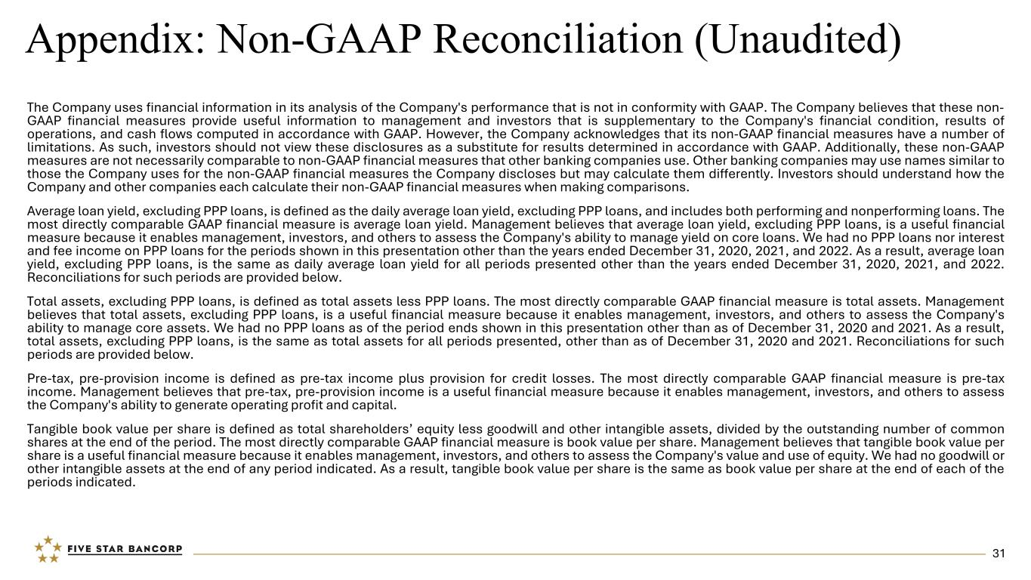
Appendix: Non-GAAP Reconciliation (Unaudited) The Company uses financial information in its analysis of the Company's performance that is not in conformity with GAAP. The Company believes that these non- GAAP financial measures provide useful information to management and investors that is supplementary to the Company's financial condition, results of operations, and cash flows computed in accordance with GAAP. However, the Company acknowledges that its non-GAAP financial measures have a number of limitations. As such, investors should not view these disclosures as a substitute for results determined in accordance with GAAP. Additionally, these non-GAAP measures are not necessarily comparable to non-GAAP financial measures that other banking companies use. Other banking companies may use names similar to those the Company uses for the non-GAAP financial measures the Company discloses but may calculate them differently. Investors should understand how the Company and other companies each calculate their non-GAAP financial measures when making comparisons. Average loan yield, excluding PPP loans, is defined as the daily average loan yield, excluding PPP loans, and includes both performing and nonperforming loans. The most directly comparable GAAP financial measure is average loan yield. Management believes that average loan yield, excluding PPP loans, is a useful financial measure because it enables management, investors, and others to assess the Company's ability to manage yield on core loans. We had no PPP loans nor interest and fee income on PPP loans for the periods shown in this presentation other than the years ended December 31, 2020, 2021, and 2022. As a result, average loan yield, excluding PPP loans, is the same as daily average loan yield for all periods presented other than the years ended December 31, 2020, 2021, and 2022. Reconciliations for such periods are provided below. Total assets, excluding PPP loans, is defined as total assets less PPP loans. The most directly comparable GAAP financial measure is total assets. Management believes that total assets, excluding PPP loans, is a useful financial measure because it enables management, investors, and others to assess the Company's ability to manage core assets. We had no PPP loans as of the period ends shown in this presentation other than as of December 31, 2020 and 2021. As a result, total assets, excluding PPP loans, is the same as total assets for all periods presented, other than as of December 31, 2020 and 2021. Reconciliations for such periods are provided below. Pre-tax, pre-provision income is defined as pre-tax income plus provision for credit losses. The most directly comparable GAAP financial measure is pre-tax income. Management believes that pre-tax, pre-provision income is a useful financial measure because it enables management, investors, and others to assess the Company's ability to generate operating profit and capital. Tangible book value per share is defined as total shareholders’ equity less goodwill and other intangible assets, divided by the outstanding number of common shares at the end of the period. The most directly comparable GAAP financial measure is book value per share. Management believes that tangible book value per share is a useful financial measure because it enables management, investors, and others to assess the Company's value and use of equity. We had no goodwill or other intangible assets at the end of any period indicated. As a result, tangible book value per share is the same as book value per share at the end of each of the periods indicated. 31

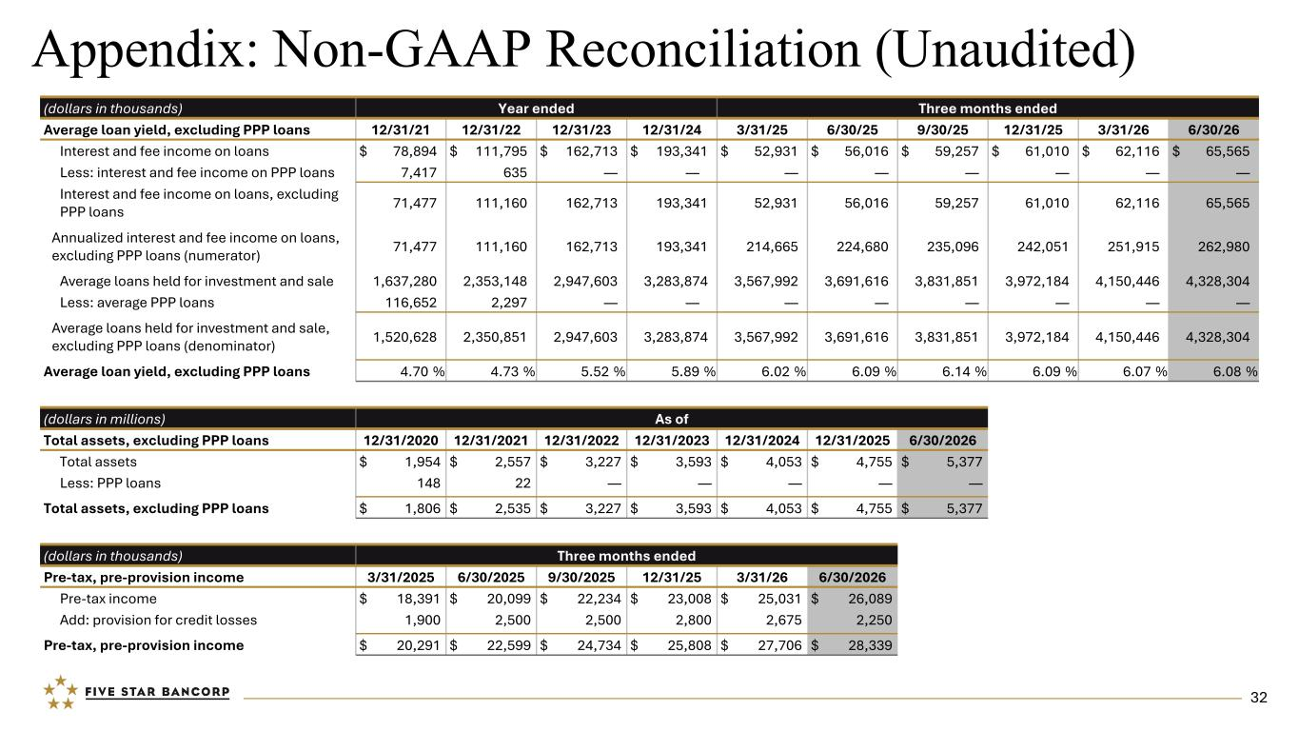
Appendix: Non-GAAP Reconciliation (Unaudited) (dollars in millions) As of Total assets, excluding PPP loans 12/31/2020 12/31/2021 12/31/2022 12/31/2023 12/31/2024 12/31/2025 6/30/2026 Total assets $ 1,954 $ 2,557 $ 3,227 $ 3,593 $ 4,053 $ 4,755 $ 5,377 Less: PPP loans 148 22 — — — — — Total assets, excluding PPP loans $ 1,806 $ 2,535 $ 3,227 $ 3,593 $ 4,053 $ 4,755 $ 5,377 (dollars in thousands) Three months ended Pre-tax, pre-provision income 3/31/2025 6/30/2025 9/30/2025 12/31/25 3/31/26 6/30/2026 Pre-tax income $ 18,391 $ 20,099 $ 22,234 $ 23,008 $ 25,031 $ 26,089 Add: provision for credit losses 1,900 2,500 2,500 2,800 2,675 2,250 Pre-tax, pre-provision income $ 20,291 $ 22,599 $ 24,734 $ 25,808 $ 27,706 $ 28,339 (dollars in thousands) Year ended Three months ended Average loan yield, excluding PPP loans 12/31/21 12/31/22 12/31/23 12/31/24 3/31/25 6/30/25 9/30/25 12/31/25 3/31/26 6/30/26 Interest and fee income on loans $ 78,894 $ 111,795 $ 162,713 $ 193,341 $ 52,931 $ 56,016 $ 59,257 $ 61,010 $ 62,116 $ 65,565 Less: interest and fee income on PPP loans 7,417 635 — — — — — — — — Interest and fee income on loans, excluding PPP loans 71,477 111,160 162,713 193,341 52,931 56,016 59,257 61,010 62,116 65,565 Annualized interest and fee income on loans, excluding PPP loans (numerator) 71,477 111,160 162,713 193,341 214,665 224,680 235,096 242,051 251,915 262,980 Average loans held for investment and sale 1,637,280 2,353,148 2,947,603 3,283,874 3,567,992 3,691,616 3,831,851 3,972,184 4,150,446 4,328,304 Less: average PPP loans 116,652 2,297 — — — — — — — — Average loans held for investment and sale, excluding PPP loans (denominator) 1,520,628 2,350,851 2,947,603 3,283,874 3,567,992 3,691,616 3,831,851 3,972,184 4,150,446 4,328,304 Average loan yield, excluding PPP loans 4.70 % 4.73 % 5.52 % 5.89 % 6.02 % 6.09 % 6.14 % 6.09 % 6.07 % 6.08 % 32

